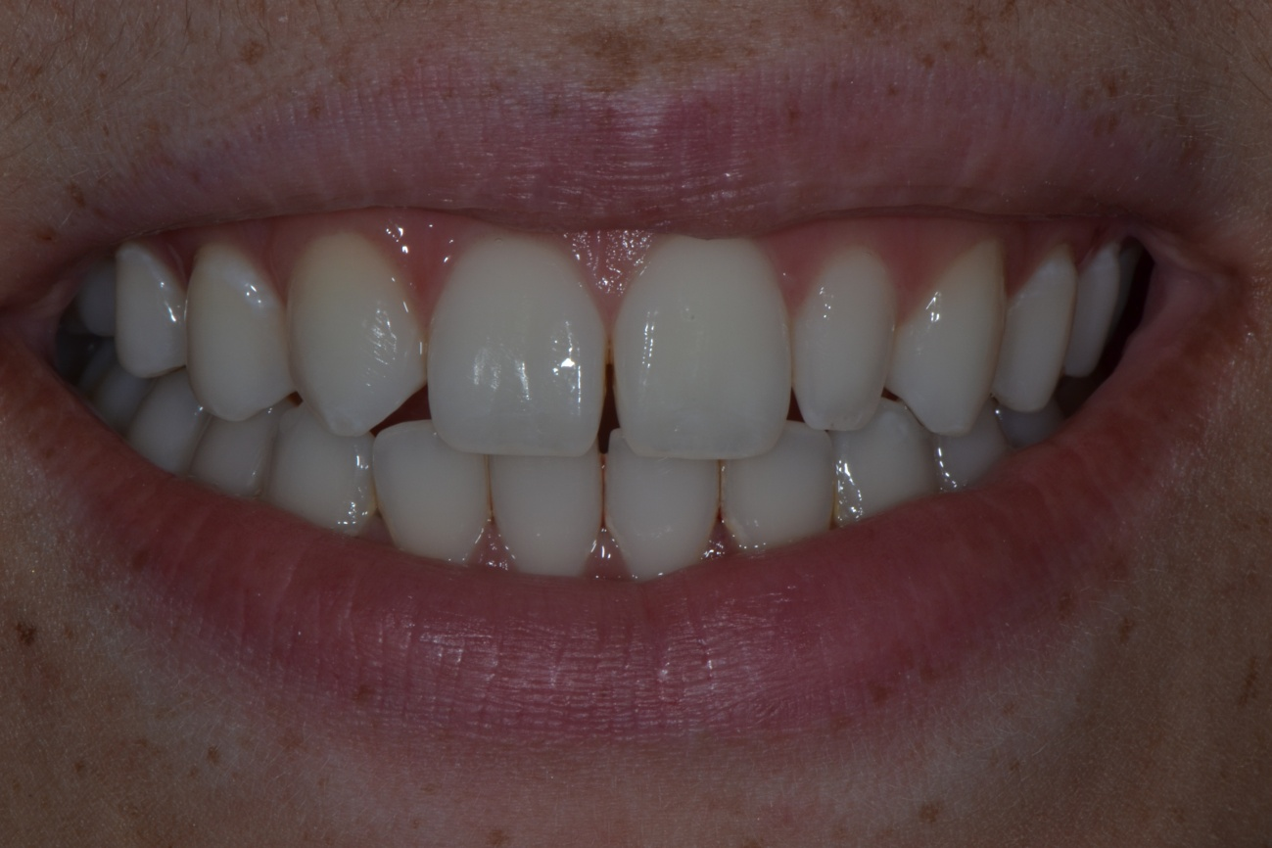
Figure 1. Preoperative photograph. Note the unevenly distributed interdental spaces among the maxillary anterior teeth and little midline deviation to the right side of the maxillary arch.

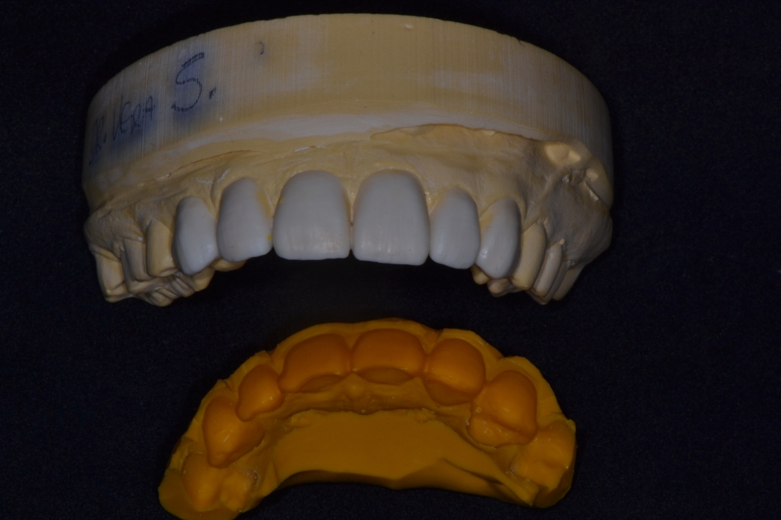
Figure 2. Wax up study. A silicone putty index made from the wax up.
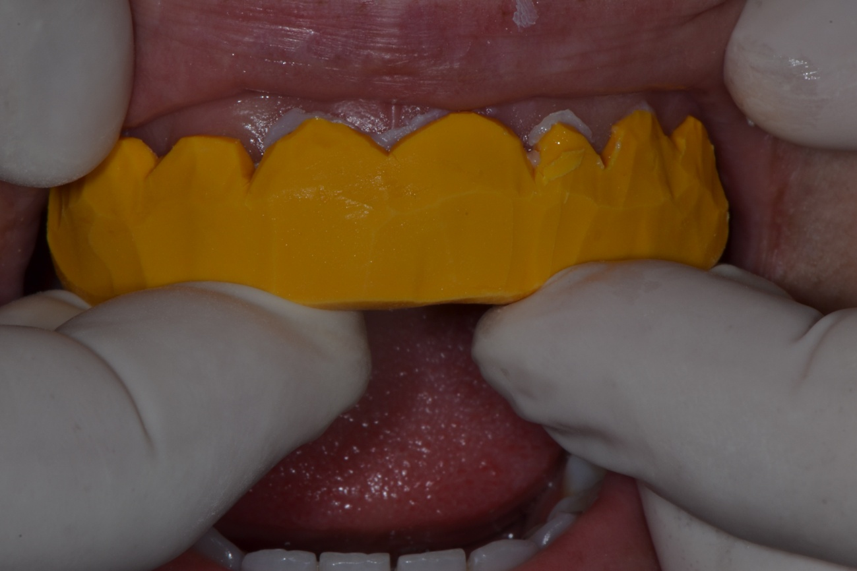
Figure 3. The silicone putty index with bisacrilic resin in position to do the mock up.
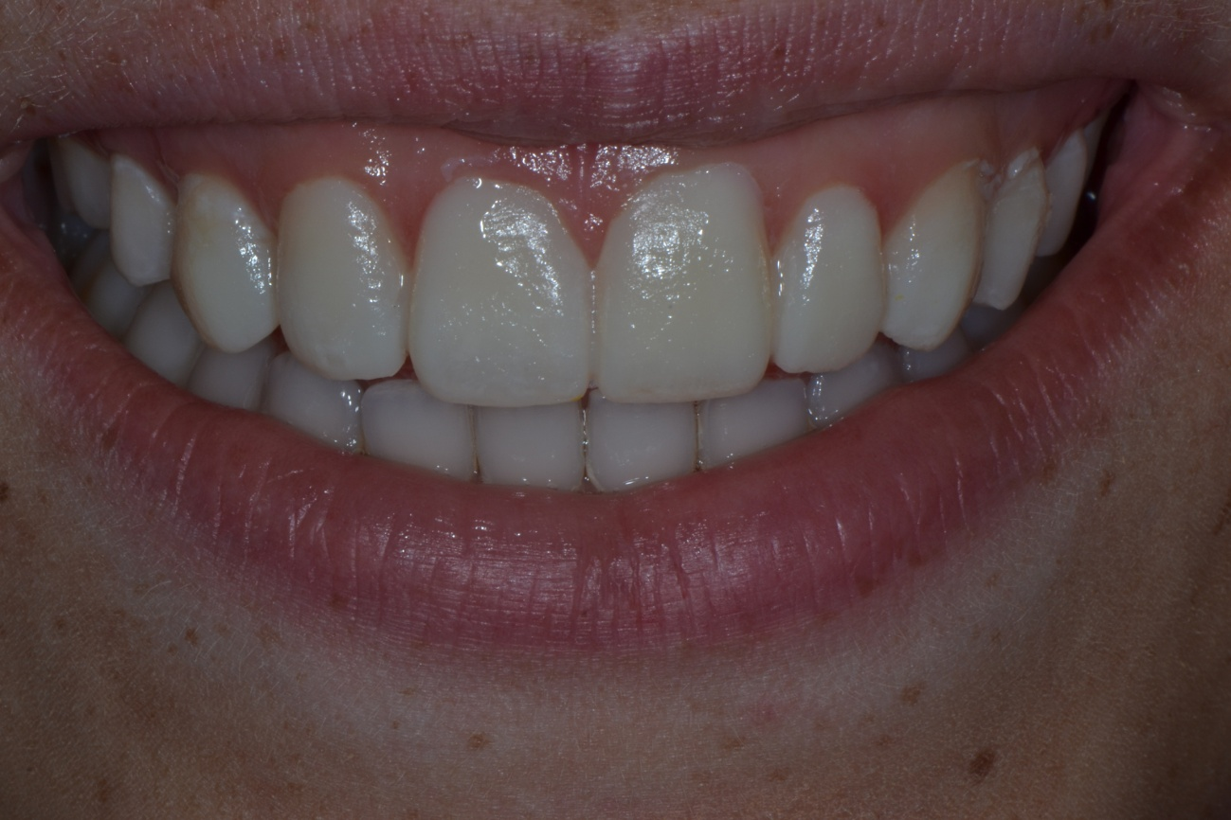
Figure 4. The mock up with bisacrilic resin.

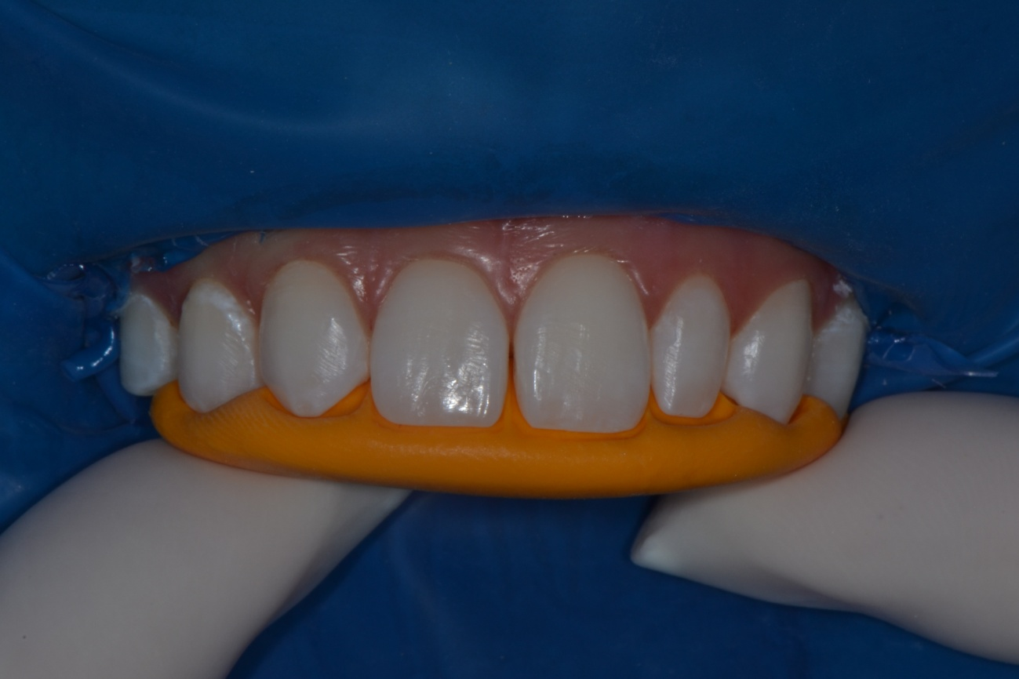
Figure 5. The silicone index positioning to observe where some burnouts should be done.

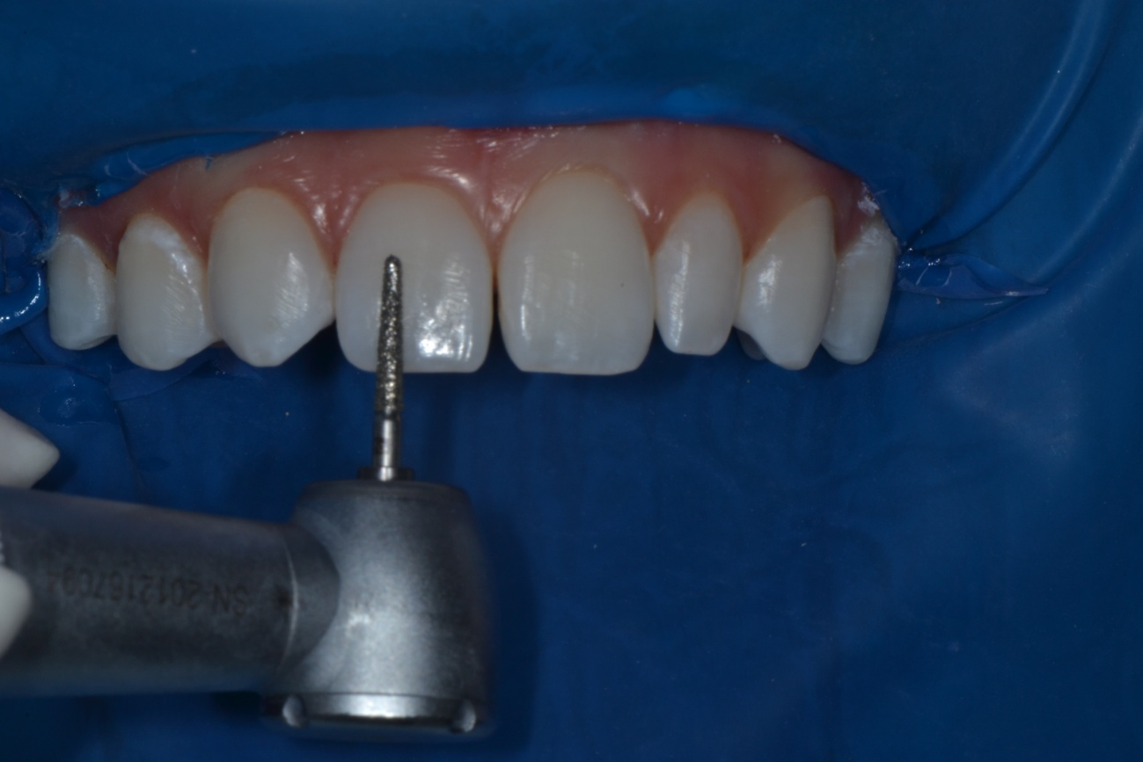
Figure 6. The burnouts with diamond bur.

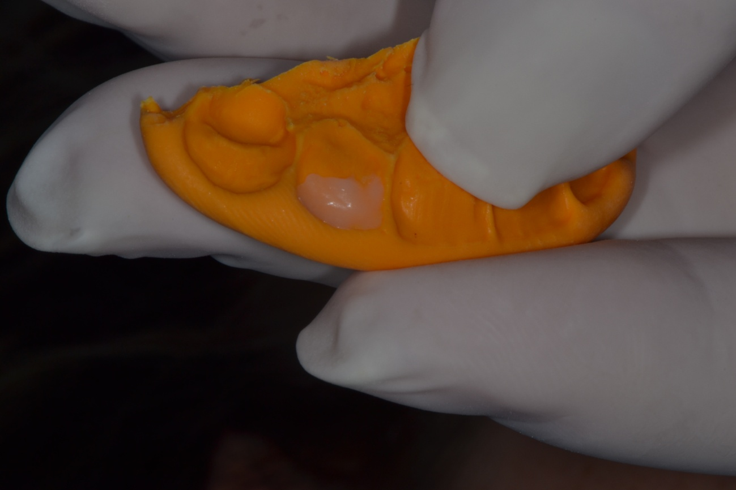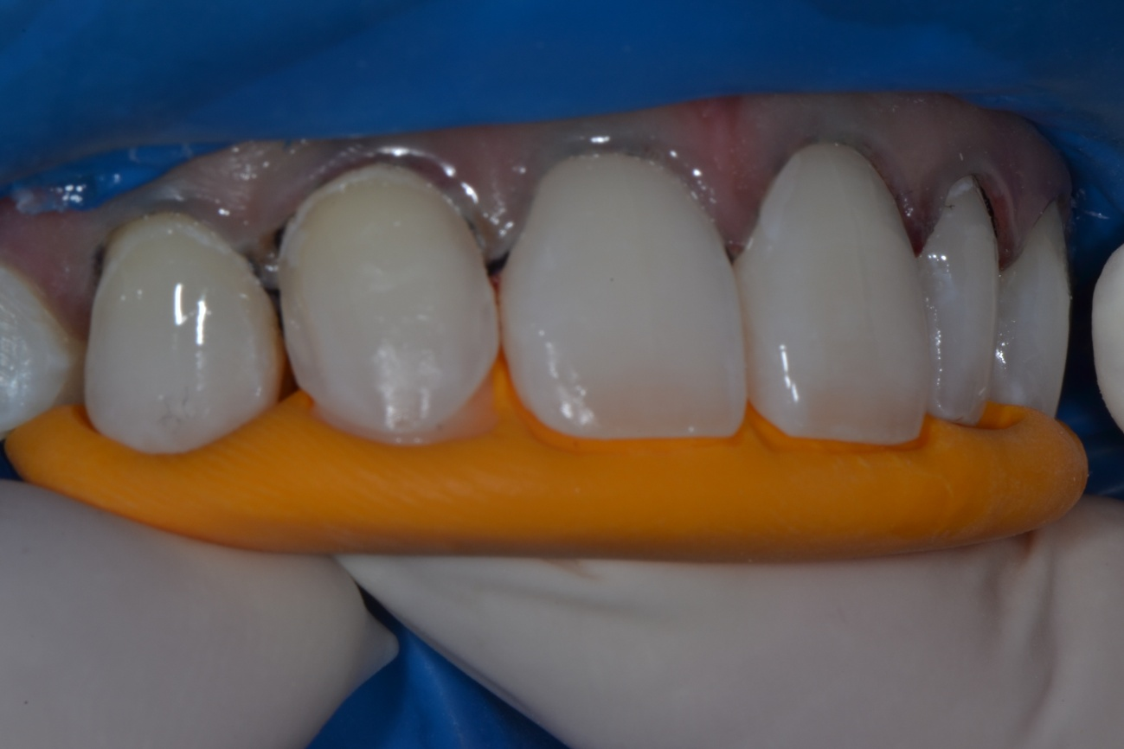
Figures 7 and 8. The use of the silicone index to build the palatal wall.

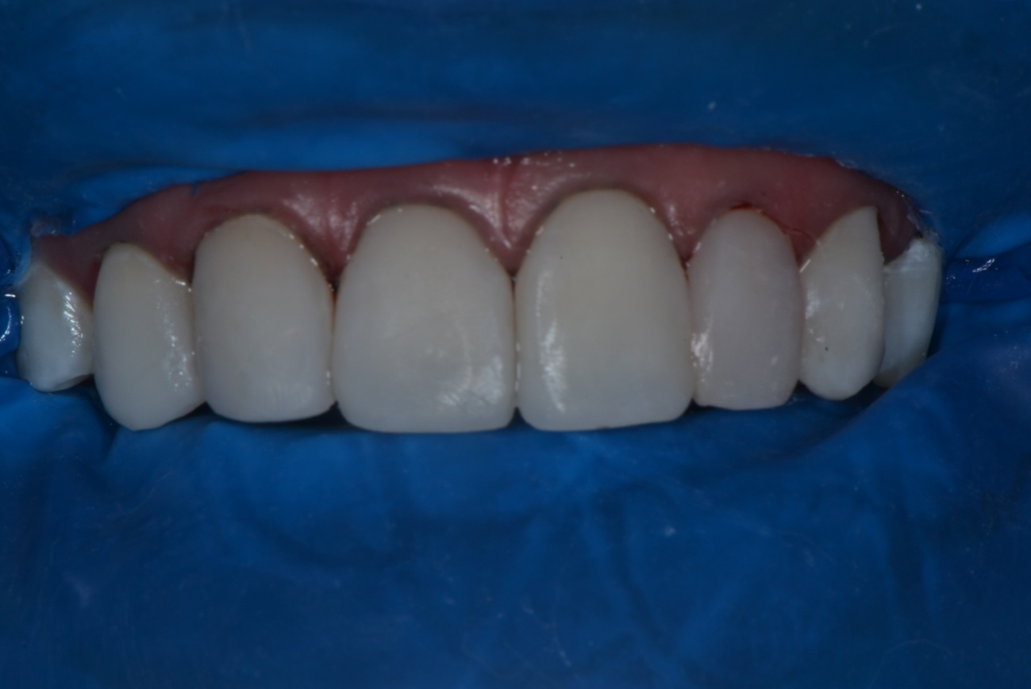
Figure 9. The final restoration without the polishing.
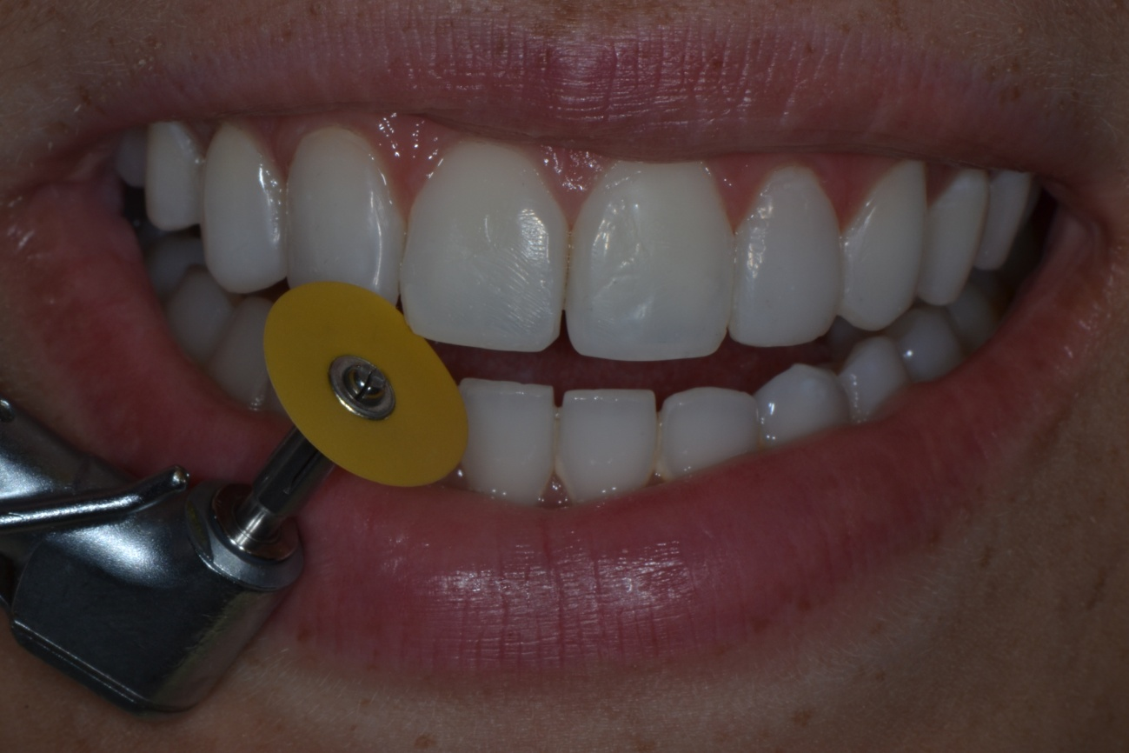
Figure 10. Finishing with sanding discs

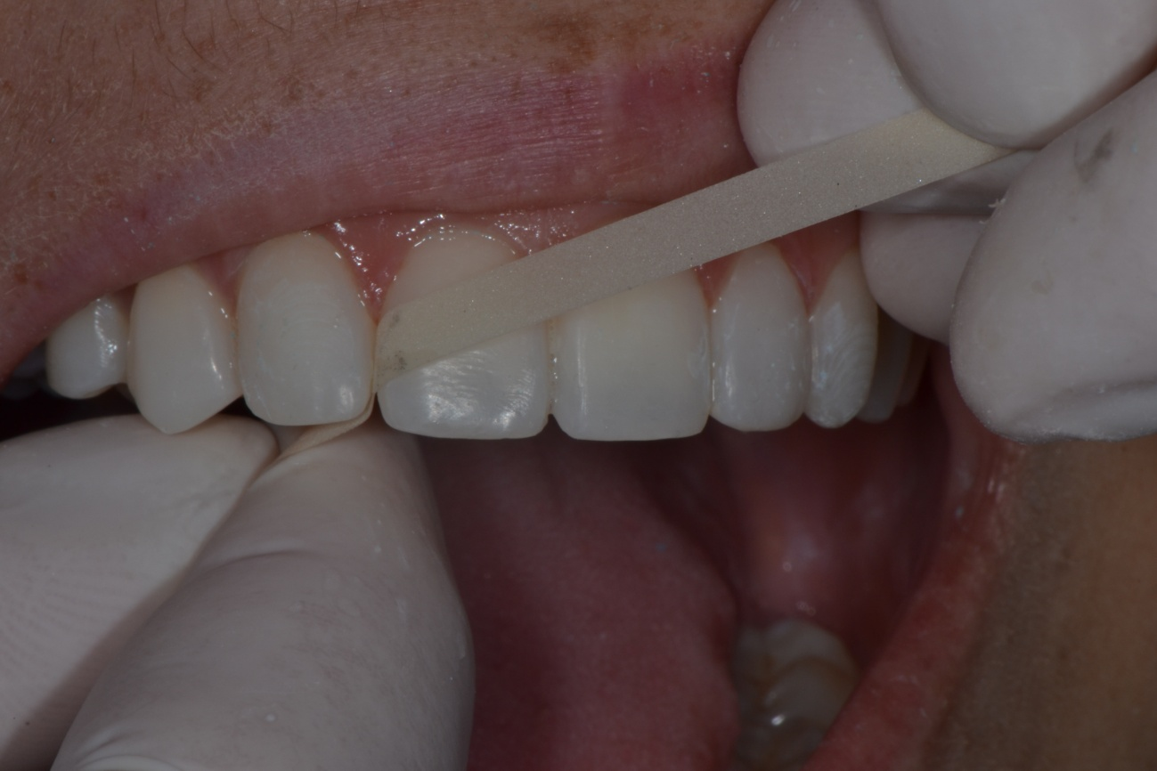
Figure 11. Finishing proximal areas with strips of sandpaper.
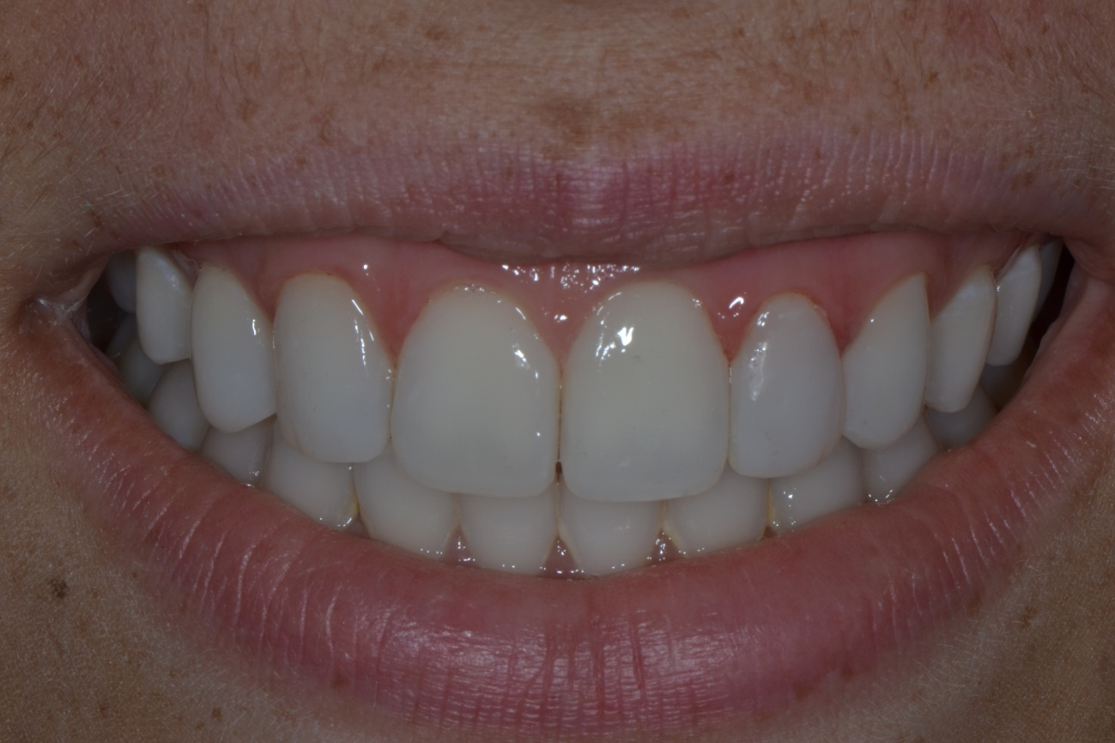
Figure 12. Post-op dental view.

