INFLUENCE OF PHOTOINITIATORS AND LIGHT SOURCES ON THE DEGREE OF CONVERSION OF EXPERIMENTAL RESIN CEMENTS

DEGREE OF CONVERSION OF RESIN CEMENTS

INFLUENCIA DE FOTOINICIADORES E FONTES DE LUZ NO GRAU DE CONVERSÃO DE CIMENTOS RESINOSOS EXPERIMENTAIS

GRAU DE CONVERSÃO DE CIMENTOS RESINOSOS
Summary:
The aim of this study was to evaluate the degree of conversion (DC) of seven experimental resin cements formulated with different photoinitiators when activated by two light-curing units (LCUs) through ceramic material. Seven resin blends with different camphorquinone (CQ) and/or phenyl propanedione (PPD) ratios were prepared: C5: 0.5% wt CQ; C8: 0.8% wt CQ; P5: 0.5% wt PPD; P8: 0.8% wt PPD; C1P4: 0.1% wt CQ and 0.4% wt PPD; C4P1: 0.4% wt CQ and 0.1% wt PPD; and C4P4: 0.4% wt CQ and 0.4% wt PPD. Each mixture was loaded with 65% wt of silanized filler particles. For photoactivation procedures, two LCUs were used: a quartz-tungsten-halogen (QTH) and a light emitting diode (LED). Irradiance (mW/cm²) was calculated by the ratio of the output power by the area of the tip. DC was assessed by Fourier transformed infrared spectroscopy. Data were submitted to a two-way ANOVA and Tukey’s test (5%). DC values do not show significant differences for LCUs regardless of the photoinitiator type. The highest DC was found for experimental cement P8 and the lowest for C5. Intermediate DC values were found for the other cements. However, when QTH was used, P8 exhibited differences among C1P4, C4P1 and C5; whereas when LED was used, P8 differed only for C4P1 and C5. Thus, PPD is a viable alternative for the manufacture of photoactivated cements, and the PPD/CQ association may also be viable since C4P4 was similar to P8.
Key Works: resin cements, curing lights, photoinitiators, dental materials.

Resumo:
O objetivo deste estudo foi avaliar o grau de conversão (DC) de sete cimentos resinosos experimentais formulados com diferentes fotoiniciadores, quando ativados por duas fontes luminosas (LCUs) atravessando a cerâmica. Sete formulações foram preparadas com diferentes concentrações (em peso) de Canforoquinona (CQ) e/ou Fenilpropanodiona (PPD): C5: 0.5% CQ; C8: 0.8% CQ; P5: 0.5% PPD; P8: 0.8% PPD; C1P4: 0.1% CQ e 0.4% PPD; C4P1: 0.4% CQ e 0.1% PPD; e C4P4: 0.4% CQ e 0.4% PPD. Cada mistura foi carregada com 65% em peso de partículas de carga silanizada. Foram usadas duas fontes luminosas para a fotoativação: uma de luz halógena de quartzo-tungstênio (QTH) e uma de diodo emissor de luz (LED). A irradiância (mW/cm²) foi calculada pela potência média de saída dividida pela área da ponta do aparelho. DC foi obtido por espectroscopia de infravermelho transformada de Fourier. Os dados foram submetidos a ANOVA 2-Fatores e ao teste de Tukey (5%). Os valores de DC não exibiram diferenças significativas para LCUs, independente do tipo de fotoiniciador. O maior DC foi observado para o cimento P8, e o menor para C5. Valores intermediários de DC foram observados nos demais cimentos. No entanto, quando usado QTH, P8 diferiu dos cimentos C1P4, C4P1 e C5; e quando o LED foi empregado, P8 diferiu apenas de C4P1 e C5. Portanto, PPD é uma alternativa viável para o desenvolvimento de cimentos resinosos fotoativados, e a associação PPD/CQ também pode ser viável, uma vez que C4P4 foi semelhante a P8.
Introduction

Camphorquinone (CQ) is the most widely used photoinitiator for visible-light-cured resins, but it has some disadvantages, such as low polymerization efficiency and toxicity (1). Furthermore, CQ is a solid, yellow compound, and even small amounts of it in resin formulations might lead to undesirable yellowing, which affects the final esthetic appearance of the cured material (2). Another major problem is that the α-diketone group, derived from CQ, has peak absorption in the visible range (468 nm) (3), resulting in fast photopolymerization under ambient light (fluorescent lamps and dental lamps) and giving a short therapeutic operation time (4). That is the reason why researchers have tested different photoinitiators in the organic matrix to substitute for or act synergistically with CQ (5-7).

Other initiators, like diphenyl-phosphine oxide (8), can be especially useful in extra white shades of resin-based composites (RBCs), often required in bleached teeth since they can eliminate the unwanted yellow effect of CQ (9). Another interesting initiator is phenyl propanedione (PPD), which may improve the polymerization kinetics. However, little is known about the effectiveness of PPD in reducing yellowing (6). Besides, the curing technology is based on the use of photoreactive systems that absorb light irradiation from light-curing units (LCUs) at the appropriate wavelength, allowing a higher degree of conversion (DC), which determines the final properties of RBCs (10).

The success of RBCs’ polymerization depends on matching the spectral emission of the LCU with the requirements of the photoinitiator system to convert the monomers into a polymer network (11). In other words, the photoinitiator activation occurs at specific wavelengths, and the optimum efficiency is obtained if the peak absorptivity of the photoinitiator corresponds with the spectral emission from the LCU (either a Light emitting diode–LED or a Quartz-tungsten-halogen–QTH). Then, it is important to consider that the PPD absorption spectrum extends from below 350 nm to approximately 490 nm, which extends into the violet range (peak at 390 nm).

Due to the lack of studies/data regarding the use of different photoinitiator systems combined with different LCUs, it is necessary to evaluate the effect of these factors on the resultant polymer properties. Therefore, the specific aim of this study was to evaluate the DC of seven experimental cements containing different photoinitiators in different ratios, photoactivated by LED or QTH through ceramic material.

The null hypotheses tested were the following:
- Similar DC values are observed in cements containing PPD or CQ, regardless of the LCU tested.
- The association PPD/CQ produces polymers with similar DCs to those of each photoinitiator by itself, regardless of the LCU tested.
- The LCUs’ irradiances or emission peaks are similar when the light is applied through a ceramic barrier.

Material and Methods

Cement preparation

Seven experimental resin cement formulations were tested in this study. The resin matrix for all formulations consisted of a combination of bisphenol glycidyl methacrylate— 50 wt% (BisGMA—Sigma- Aldrich Inc., St. Louis, MO, USA), urethane dimethacrylate—30 wt% (UDMA—Sigma-Aldrich Inc., St. Louis, MO, USA) and triethylene glycol dimethacrylate—20 wt% (TEGDMA—Sigma-Aldrich Inc., St. Louis, MO, USA). Composites were loaded with 65 wt% silanized filler (7) (25 wt% silica with 0.04 μm - Nippon Aerosil Co. Ltd., Yokkaichi, Tokyo, Japan - and 75 wt% Ba-Al-Si glass with 0.5 μm —Esstech Inc., Essington, Pennsylvania, USA.).

The difference among the cements was the photoinitiator system (camphorquinone—CQ or phenyl propanedione—PPD; Sigma-Aldrich Inc., St. Louis, MO, USA), whereas 1.0% dimethylaminoethyl methacrylate (DMAEMA—Sigma-Aldrich Inc., St. Louis, MO, USA) was always used as co-initiator and 0.1% hydroquinone as inhibitor. Therefore, the following photoinitiator systems were tested (Table 1):

Table 1 – The experimental groups and photoinitiator ratios.
Groups | Photoinitiators
Groups | CQ (%wt) | PPD (%wt)
C5 | 0.5 | ---------
C8 | 0.8 | ---------
P5 | --------- | 0.5
P8 | --------- | 0.8
C1P4 | 0.1 | 0.4
C4P1 | 0.4 | 0.1
C4P4 | 0.4 | 0.4

The LCUs used in the study were one QTH (XL2500, 3M/ESPE, St. Paul, MN, USA) and one LED (UltraLume LED5, Ultradent Products Inc., South Jordan, Utah, USA) with standardized diameters of the LCU tips at 7 mm by using a centered black cover. All LCUs were analyzed with the standardization of the tip to certify that the black cover would not affect the quality of light emission, mainly of the UltraLume LED5.

The output power (mW) of each LCU was measured with a calibrated power meter (Ophir Optronics, Har-Hotzvim, Jerusalem, Israel). Thus, the light irradiance (mW/cm²) was determined by dividing the output power by the tip area. Spectral distributions were obtained by using a calibrated spectrometer (USB2000, Ocean Optics, Dunedin, FL, USA). The irradiance and the spectral distribution data were integrated using the Origin 6.0 software (OriginLab, Northampton, MA, USA).

Photoinitiators

The photoinitiators CQ (Sigma-Aldrich Inc., St. Louis, MO, USA) and PPD (Sigma-Aldrich Inc., St. Louis, MO, USA) were used as delivered. Absorption spectra were determined using a UV-Vis spectrophotometer (Varian Cary 5G, Sydney, New South Wales, Australia). Only the visible and near UV range was of interest (350–550 nm), as this range reflects the emission of LCUs. Absorption spectra were recorded for each photoinitiator separately (CQ and PPD).

Degree of conversion

The cements prepared for FTIR spectroscopy analysis (Bomem, model MB-102, Montreal, Quebec, Canada) were applied in a circular mold (7 mm in inner diameter and 1 mm in height), upon which circular discs (7 mm in diameter x 1.4 mm in height) of feldspathic glass ceramic material (IPS e.max Ceram, shade A3, Ivoclar-Vivadent, Liechtenstein) were placed under a fixed load of 0.4 N. The photoactivation of the resin cements was conducted using UltraLume LED5 or XL2500 for 100 seconds.

After 24 h at 37 °C and light protected, each specimen was finely pulverized using a hard tissue-grinding machine (Marconi, model MA590, Piracicaba, SP, Brazil). After that, 10 mg of the ground powder was mixed with 100 mg of KBr (Aldrich, Milwaukee, WI, USA) powder salt. This mixture was placed into a pelleting device (Aldrich, Milwaukee, WI, USA) and then pressed in a hydraulic press (Carver Laboratory Press, model 3648, Wabash, St. Morris, USA) with a load of 8 tons to obtain a pellet. This pellet was placed in a holder attachment within the spectrophotometer (Bomem, model MB-102, Montreal, Quebec, Canada) for analysis. The uncured composite was analyzed using a metal siliceous window.

The measurements were recorded in absorbance mode with a FTIR spectrometer (Bomem, model MB-102, Montreal, Quebec, Canada) operating under the following conditions: 300–4000 cm⁻¹ wavelength; 4 cm⁻¹ resolution; 32 scans. The percentage of unreacted carbon–carbon double bonds (C=C) was determined from the ratio of absorbance intensities of aliphatic C=C (peak at 1638 cm⁻¹) against the internal standard (aromatic C=C, peak at 1608 cm⁻¹) before and after curing the specimen. The degree of conversion was determined by subtracting the % C=C from 100%. All experiments were carried out in triplicate.

Statistical analysis

The data were submitted to a two-way ANOVA. Comparisons of the means were made using Tukey’s post-hoc test (p ≤ 0.05).

Results

Table 2 exhibits the mean of DC (Standard Deviation—SD) of the seven experimental cements polymerized by the two LCUs. The two-way ANOVA showed significant differences for the interaction of the two independent variables studied (cement and LCU) and for the cement Factor (p < 0.05), but not for the LCU Factor.

Table 2 – Mean (SD) degree of conversion (%) of the experimental cements light-cured by QTH and LED.

CEMENT | QTH (%) | LED (%)
P8 | 60.0 (1.6) a, A | 58.8 (4.3) a, A
C4P4 | 57.6 (0.4) a, A | 56.2 (3.9) ab, A
P5 | 54.0 (1.1) ab, A | 55.3 (0.3) ab, A
C8 | 54.1 (3.7) ab, A | 54.5 (2.4) abc, A
C1P4 | 50.7 (1.8) bc, A | 53.3 (1.7) abc, A
C4P1 | 50.4 (1.2) bc, A | 50.9 (3.0) bc, A
C5 | 47.1 (1.2) c, A | 48.4 (2.5) c, A
Means followed by different capital letters in the same line and small letters in the same column were significantly different (p < 0.05).

The P8 cement presented the higher DC for both QTH and LED, irrespective of LCU; however, when polymerized by QTH, P8 presented statistical differences for C1P4, C4P1 and C5. When polymerized by LED, the differences were only for C4P1 and C5. The C5 cement exhibited the lowest DC, irrespective of LCU, and when polymerized by QTH presented no statistical differences for C1P4 and C4P1. When polymerized by LED, it was similar to C8, C1P4 and C4P1.

The spectra of the photoinitiators and LCUs used in this study are shown in Table 3. The UltraLume LED5 showed the highest irradiance values (1300 mW/cm² and 715 mW/cm² when passed across 1.4 mm of ceramic material), with emission peaks at 454 and 402 nm, whereas XL2500 showed the lowest values (850 mW/cm² and 460 mW/cm² when passed across 1.4 mm of ceramic material), with an emission peak at 490 nm. The light absorption analysis of dental photoinitiators showed that CQ exhibited an absorption centered in the blue region of the light spectrum, with Abs_{max} at 470 nm, while PPD’s spectral absorption initiates in the UV region and extends into the visible region, with Abs_{max} at 398 nm.

Table 3 – Irradiance values and emission peaks of light-curing units applied with or without a ceramic barrier.
Ceramic Disc |  | Light-Curing Unities
Ceramic Disc |  | QTH (XL2500) | LED (UltraLume LED5)
No | Irradiance | 850 mW/cm² | 1300 mW/cm²
No | Emission Peak | 487 nm | 454 and 402 nm
Yes | Irradiance | 460 mW/cm² | 715 mW/cm²
Yes | Emission Peak | 491 nm | 454 and 402 nm

Table 3 shows the LCUs’ irradiance values and emission peaks, with and without the 1.4-mm-thick ceramic bar shade A3. The irradiance values decreased when the light passed through the ceramic barrier, whereas the emission peaks were maintained at a similar level.

Figures 1 and 2 show the spectra of the LCUs used in this study when applied with or without a ceramic barrier.

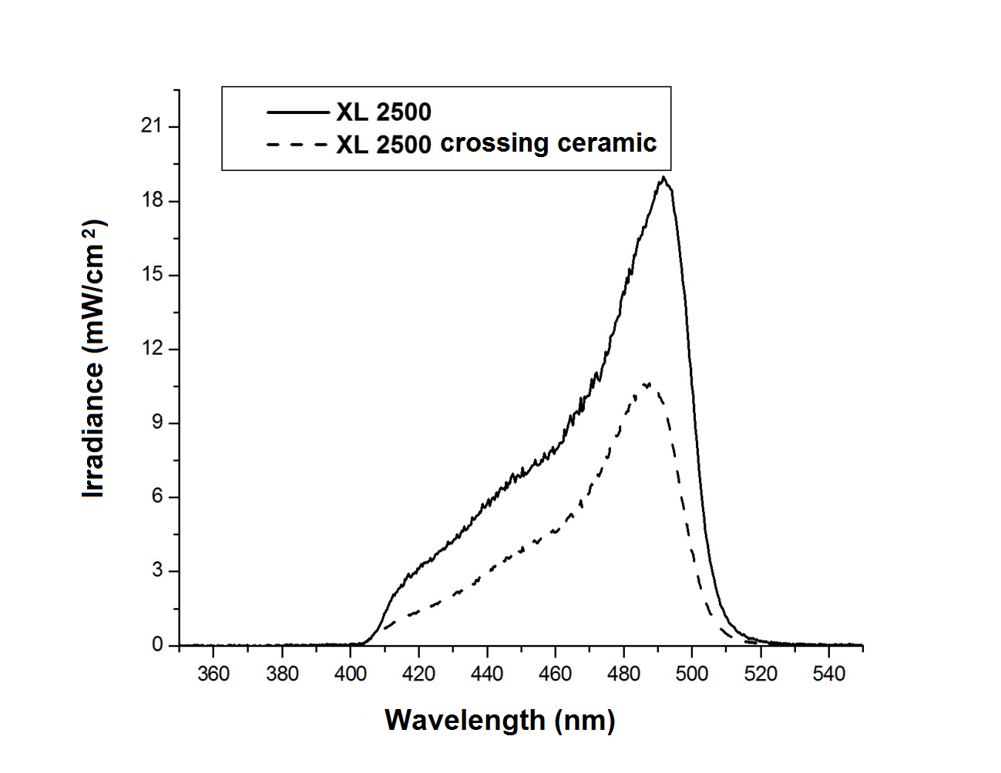
Figure 1 – QTH—XL2500 spectra applied with or without a a ceramic barrier.

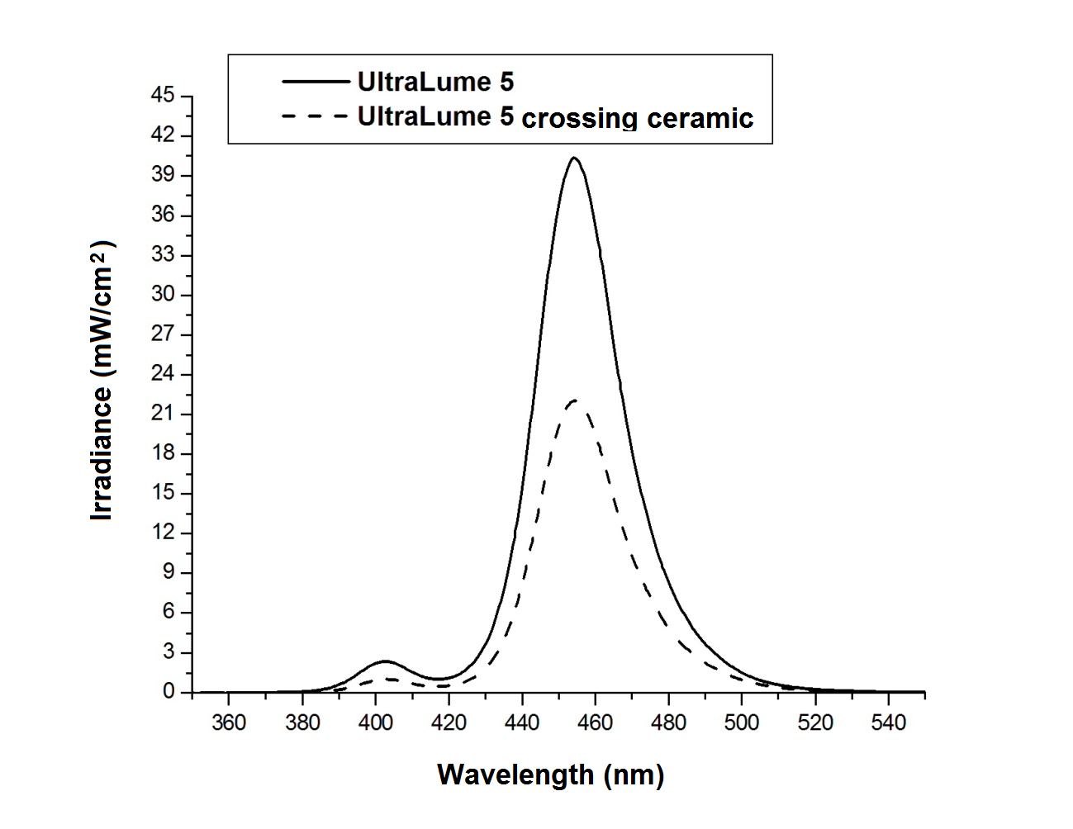
Figure 2 – UltraLume LED5 spectra applied with or without a ceramic barrier.

Discussion

Degree of conversion is an important parameter influencing the final physical and biological properties of RBCs (12). Lower DC values mean higher ratios of non-polymerized material, enabling its leaching and thus compromising the material properties (13). Many factors can affect the polymerization efficiency, be they intrinsic (photoinitiator type and concentration, matrix viscosity and optical properties) or extrinsic (light type and spectrum, irradiation parameters, curing mode, temperature and light guide tip positioning) (14). This study evaluated the emission of LCUs and the absorption spectra of photoinitiators in order to determine the influence of the relationship between LCUs and the spectra of the photoinitiators on the final DC of experimental dental cements.

Considering that the traditional CQ/amine system presents some disadvantages, studies on alternative photoinitiator systems for RBCs are important and are still under construction. In 1998, CHAE & SUN (1) proposed PPD as a new visible light photosensitizer for dental composite resin with higher efficiency than CQ, and in 1999, PARK et al (6) stated PPD was like an efficient light photosensitizer, comparable to CQ, and found a synergic action between PPD and CQ. Thus, investigations were made into the relationship between light-curing units and photoinitiators, the presence of synergy between CQ and PPD and, furthermore, the light irradiance and emission peak reaching the experimental cements formulated with CQ, PPD and CQ/PPD (all containing amine) when light is applied through ceramic discs (15). The light-cured resin cements are often elected for fixing ceramic crowns and veneers on anterior teeth due to allowing light to pass relatively better, ensuring good bond strength (16), since Akgungor et al. (2005) (17) advocate that up to a thickness of 2 mm, there was no effect deleterious on bond strength.

The results agree with some studies (1,6) in regard to PPD efficiency; however, they disagree in regard to the synergic action. The possible reasons for the different results may be due to different photoinitiators and compositions having been used in each study. Therefore, the first null hypothesis tested was refuted, and the second one was not.

Since PPD and CQ have different wavelength absorption ranges, PPD was chosen because it would be a better UV initiator than an efficient visible light photoinitiator. Otherwise, this can be a disadvantage for the conversion of C=C since very little energy would be concentrated in this spectral range (390 nm) (18). In addition, PPD is used in RBCs due to possessing a larger extinction coefficient than CQ. The extinction coefficient is the probability of a molecule absorbing light (19). Photoinitiators with high molar extinction coefficients are better able to absorb photons, produce free radicals and, presumably, contribute to higher values ​​of the DC. Within these concepts, an alternative photoinitiator group of α-diketones was tested, which potentially could become a viable choice to replace CQ.

Both of these photoinitiators (CQ and PPD) can be used without any co-initiator in light-curable dental composites, but to decrease their concentrations, they are used with different co-initiators. The reason is simply that too high of a photoinitiator concentration affects the color of the dental composite (2). Therefore, to enhance the photoinitiator efficiency at lower concentrations, a 1.0% wt of co-initiator (DMAEMA) in a fixed dosage (2:1—co-initiator/photoinitiator, respectively, adjusted for 0.5% of initiator) was used in agreement with other studies that found larger DC values in that proportion when DMAEMA was used with CQ (20).

If the amine rate is lower than that of CQ, the spontaneous collision of the two substances becomes difficult, and some molecules of CQ in triplet state return to the fundamental state, compromising the generation of free radicals. However, if the amine concentration is higher than that of CQ, the production of radicals depends only on the reactivity of the system since the collision of molecules is assured (21). That is why the amine was also used with the PPD, allowing a comparison of the two photoinitiators in the same conditions. But, the excess amine can also lead to excessive yellowing of the material, which is not desirable in ceramic laminate; so the concentration was limited to 1.0%.

The DC and physical properties of dental composites are dependent on the total amount of available light energy (energy dose) during polymerization (22). However, this correlation is not linear because significant increase in the conversion of C=C is not expected to happen with energy doses above certain values (23). The present study showed similar results for the two light sources. This is likely due to the fact that both the UltraLume LED5 and the QTH—XL2500 deliver a wide range of wavelengths (Figures 1 and 2) and thus were able to adequately initiate both the CQ and the PPD, generating values ​​of DC to the point of equating them statistically.

The development of efficient photoinitiators allows ultrafast photopolymerization (24), and also LCU technologies are driven to satisfy the demands of clinical practitioners to reduce chairside operation time. But it is essential to effectively polymerize light-activated resin-based composite (RBC) materials. Therefore, we must consider the evidence suggesting that irradiance and time independently affect the mechanical and physical properties of cured resins and RBCs (25).

The results show that the P8 cement presented the highest DC, and the C5 cement exhibited the lowest DC, irrespective of the LCU. These results are probably due to the fact that higher concentrations of photoinitiators tend to increase the degree of conversion up to a certain point (6). A slight superiority of PPD over CQ was observed. This can be noted since the experimental cements containing identical concentrations of one or the other initiator (C5: P5; C8: C1P4 and P8: P1C4) showed consistently higher DC values ​​in cements containing PPD for the two light sources. This suggests a trend, but a statistically significant difference was only observed between C5 and C8/QTH.

Another aspect that must be considered is the ceramic disc with a 1.4-mm-thick color A3 dentin/enamel interposed between the light source and the cementing agent, which decreased the final irradiance for both LCUs (26). Thicker or darker ceramic restorations are an obstacle to light and can reduce the quality and the quantity of light incidence on resin cement, often compromising the final polymerization (27). The results (Table 3) showed that after going through the ceramic discs, light irradiance was reduced, but there was no change in the emission peaks for the two light sources. Therefore, it became necessary to employ an increased polymerization time of 100 s. Thus, the third null hypothesis tested was partially refuted.

PPD is a viable alternative in the formulation of photocured resin cements because it allows the reduction or elimination of CQ, which is yellowish, without impairing the degree of conversion, especially considering the high demand for esthetic restorations. Furthermore, both LED and QTH are effective in curing the resin cements containing PPD or CQ, ensuring a desired degree of conversion even on a ceramic color A3 disc 1.4 mm in thickness.

References

- Chae KH, Sun GJ. Phenylpropanedione: A new visible light photosensitizer for dental composite resin with higher efficiency than Canphorqinone. Bull Korean Chem Soc 1998; 19: 152-4.
- Schneider LFJ, Pfeifer CSC, Consani S, Prahl SA, Ferracane JL. Influence of photoinitiator type on the rate of polymerization, degree of conversion, hardness and yellowing of dental resin composites. Dent Mater 2008; 24: 1169-77.
- Santini A, Gallegos IT, Felix CM. Photoinitiators in dentistry: a review. Prim Dent J. 2013 Oct;2(4):30-3. Review.
- Ikemura K, Ichizawa K, Jogetsu Y, Endo T. Synthesis of a novel camphorquinone derivative having acylphosphine oxide group, characterization by UV-VIS spectroscopy and evaluation of photo polymerization performance. Dental Materials Journal 2010; 29:122-31.
- Soares EF, Costa AR, Correr AB, Vedovello SA, Vedovello Filho M, Ogliari FA, de Moraes RR, Correr-Sobrinho L. Effect of composite containing an iodonium salt on the bond strength of brackets to bovine enamel. Braz Dent J. 2014; 25(3):237-40.
- Park YJ, Chae KH, Rawls HR. Development of a new photoinitiation system for dental light-cured composites resin. Dent Mat 1999; 15:120-7.
- Oliveira DC, Silva CB, Muniz BV, Volpato MC, Costa AR, Sinhoreti MA.Effect of 4-(N,N-dimethylamino)phenethyl Alcohol on Degree of Conversion and Cytotoxicity of Photo-Polymerized CQ-Based Resin Composites. Braz Dent J. 2014 Dec; 25(6):538-42.
- Miletic V, Santini A. Micro-Raman spectroscopic analysis of the degree of conversion of composite resins containing different initiators cured by polywave or monowave LED units. J Dent 2012; 40: 106–13.
- Arikawa H, Takahashi H, Kanie T, Ban S. Effect of various visible light photoinitiators on the polymerization and color of light-activated resins. Dental Materials Journal 2009; 28:454-60.
- Moraes RR, Brandt WC, Naves LZ, Correr-Sobrinho L, Piva E. Light- and time-dependent polymerization of dual-cured resin luting agent beneath ceramic. Acta Odontol Scand. 2008 Oct;66(5):257-61.
- Gajewski VE, Pfeifer CS, Fróes-Salgado NR, Boaro LC, Braga RR. Monomers used in resin composites: degree of conversion, mechanical properties and water sorption/solubility. Braz Dent J. 2012; 23(5):508-14.
- Brandt WC, de Moraes RR, Correr-Sobrinho L, Sinhoreti MA, Consani S. Effect of different photo-activation methods on push out force, hardness and cross-link density of resin composite restorations. Dent Mater. 2008 Jun; 24(6):846-50.
- Ferracane JL. Hygroscopic and hydrolytic effects in dental polymer networks. Dent Mater. 2006 Mar; 22(3):211-22.
- Leprince JG, Palin WM, Hadis MA, Devaux J and Leloup G. Progress in dimethacrylate-based dental composite technology and curing efficiency. Dent Mater 2013; (29): 139–156.
- Runnacles P, Correr GM, Baratto Filho F, Gonzaga CC1, Furuse AY. Degree of conversion of a resin cement light-cured through ceramic veneers of different thicknesses and types. Braz Dent J. 2014 Jan-Feb; 25(1):38-42.
- Ikemura K, Ichizawa K, Jogetsu Y, Endo T. Synthesis of a novel camphorquinone derivative having acylphosphine oxide group, characterization by UV-VIS spectroscopy and evaluation of photo polymerization performance. Dental Materials Journal 2010; 29:122-31.
- Akgungor G, Akkayan B, Gaucher H. Influence of ceramicthickness and polymerization mode of a resin luting agenton early bond strength and durability with a lithiumdisilicate-based ceramic system. J Prosthet Dent2005;94:234–41.
- Brandt WC, Schneider LFJ, Frollini E, Correr-Sobrinho L, Sinhoreti MAC. Effect of different photo-initiators and light curing units on degree of conversion of composites. Braz Oral Res 2010; 24: 263-70.
- Shin DH, Rawls HR. Degree of conversion and color stability of the light curing resin with new photoinitiator systems. Dent Mater. 2009 Aug;25(8):1030-8.
- Teshima W, Nomura Y, Tanaka N, Urabe H, Okazaki M; Nahara Y. ESR study of camphorquinone/amine photoinitiator systems using blue light-emitting diodes. Biomaterials. 2003; 24(12): 2097-103.
- Cook WD. Photopolymerization kinetics of dimethacrylates using the camphorquinone/amine initiator system. Polymer 1992; 33(3): 600-9.
- Halvorson RH, Erikson RL, Davidson CL. Energy dependent polymerization of resin-based composite. Dent Mater 2002; (18):463-9.
- Calheiros FC, Braga RR, Kawano Y, Ballester RY. Relationship between contraction stress and degree of conversion in restorative composites. Dent Mater 2004;(20):939-46.
- Randolph LD, , Palin WM, Bebelman S, Devaux J, Gallez B, Leloup G and Leprince JG. Ultra-fast light-curing resin composite with increased conversion and reduced monomer elution. Dent Mater 2014; (30): 594–604.
- Randolph LD, Palin WM, Watts DC, Genet M, Devaux J, Leloup G and Leprince JG. The effect of ultra-fast photopolymerisation ofexperimental composites on shrinkage stress,network formation and pulpal temperature rise. Dent Mater 2014; 30(11):1280-9.
- O’Keef KL, Pease PL, Herrin HK. Variables affecting the spectral transmittance of light through porcelain veneers. J Prosthet Dent 1991;(66):434-8.
- Myers ML, Caughman WF, Rueggeberg FA. Effect of restoration composition, shade, and thickness on the cure of a photoactivated resin cement. J Prosthodont 1994;(3):148-57.

