Captions to figures:
Figs 1a-b. a) The mean biaxial flexural strength values (MPa) for zirconia systems with and without glazing, b) Dot plot figure demonstrating the distribution of biaxial flexural strength values (MPa) around the mean value for the unglazed and glazed zirconia.
Figs 2a-b. a) The mean biaxial flexural strength values (MPa) for unglazed zirconia systems without and with thermal cycling, b) Dot plot figure demonstrating the distribution of biaxial flexural strength values (MPa) around the mean value for the unglazed zirconia without and with thermal cycling.
Figs 3a-b. a) The mean biaxial flexural strength values (MPa) for glazed zirconia systems without and with thermal cycling, b) Dot plot figure demonstrating the distribution of biaxial flexural strength values (MPa) around the mean value for the glazed zirconia without and with thermal cycling.
Fig 4. The mean Vickers hardness values (VHN) for unglazed glazed zirconia systems without and with thermal cycling.
Figures

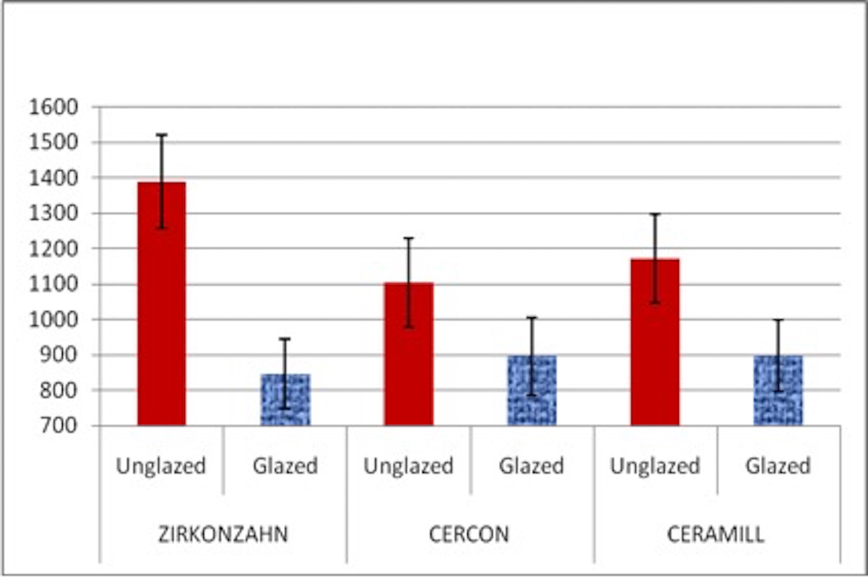

Fig 1a. The mean biaxial flexural strength values (MPa) for zirconia systems with and without glazing.

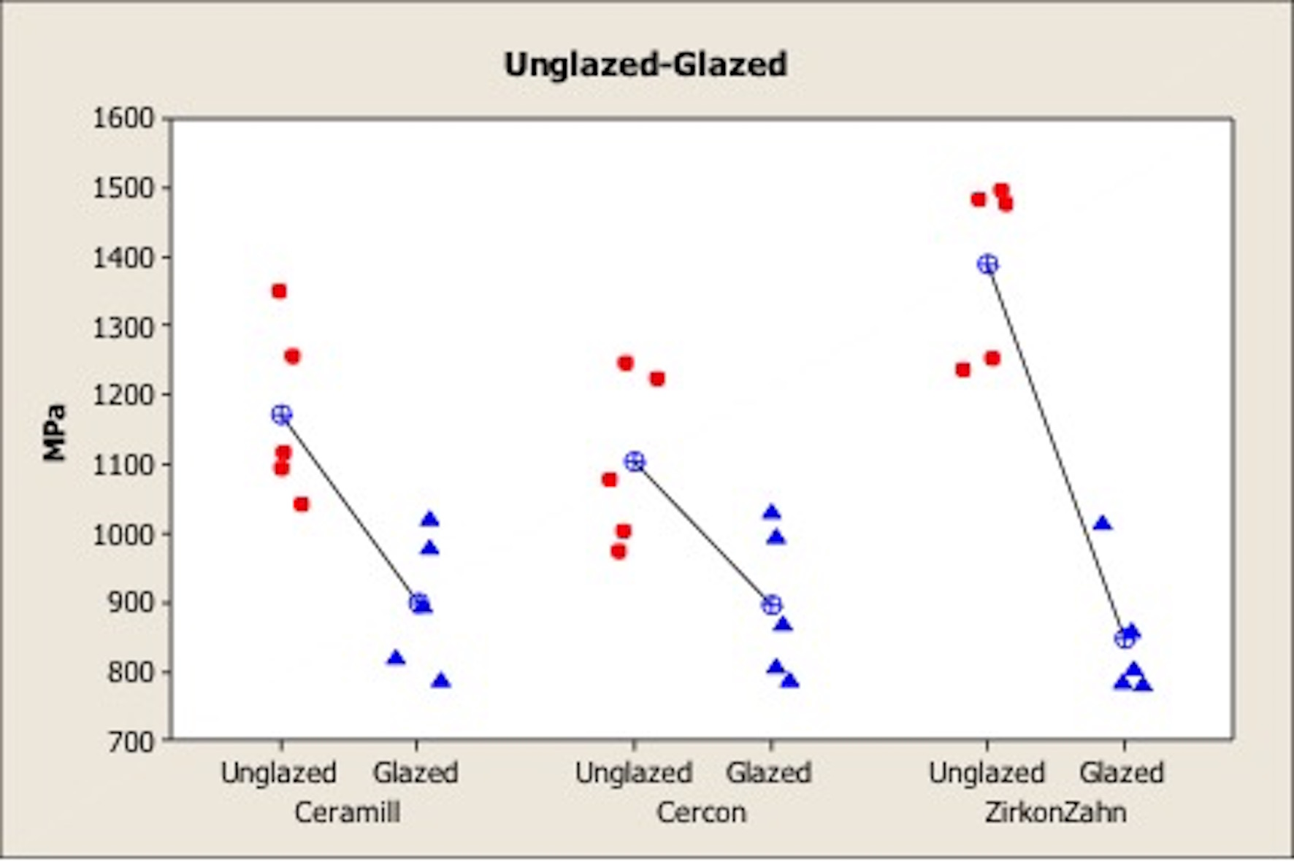
Fig 1b. Dot plot figure demonstrating the distribution of biaxial flexural strength values (MPa) around the mean value for the unglazed and glazed zirconia.

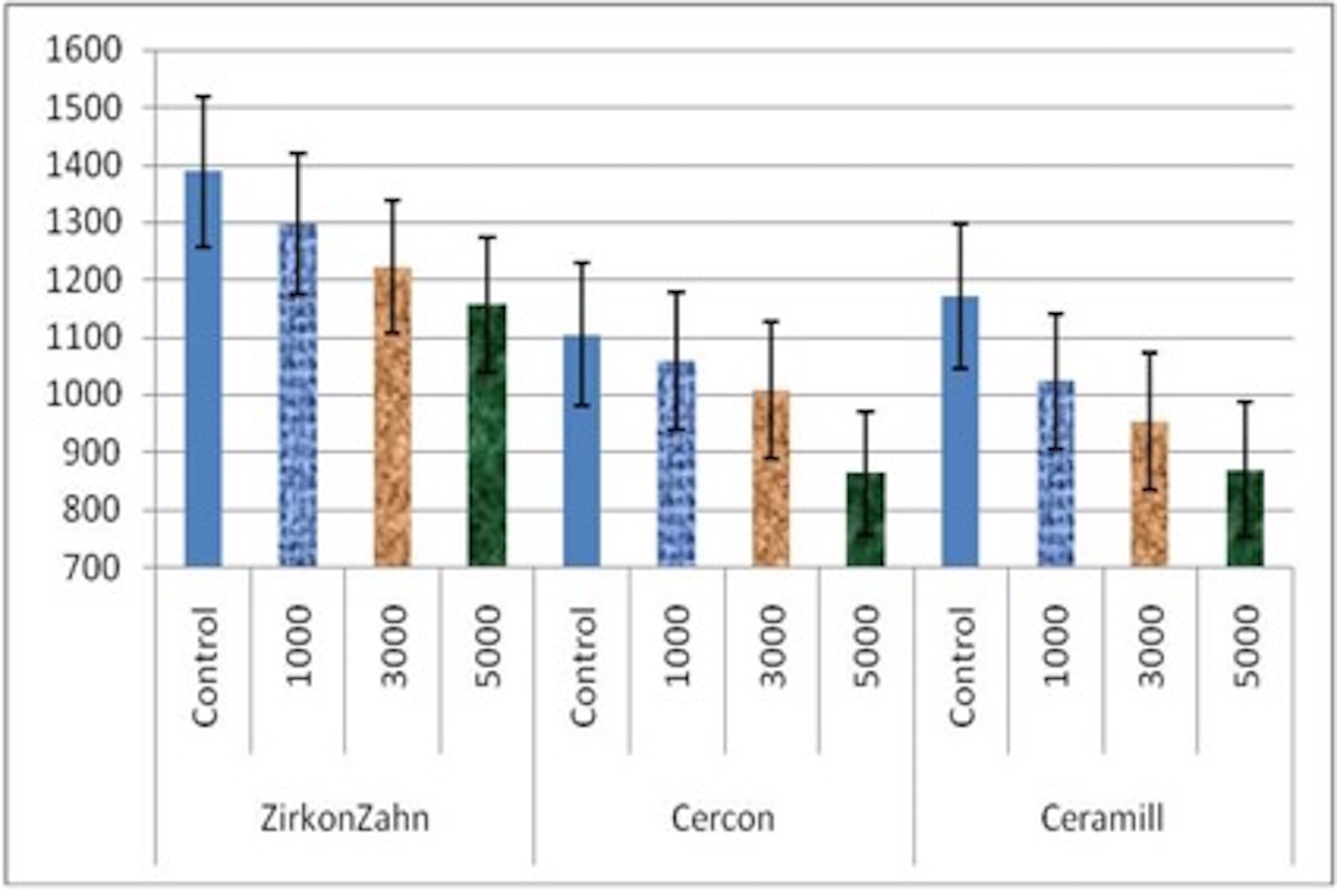

Fig 2a. The mean biaxial flexural strength values (MPa) for unglazed zirconia systems without and with thermal cycling.

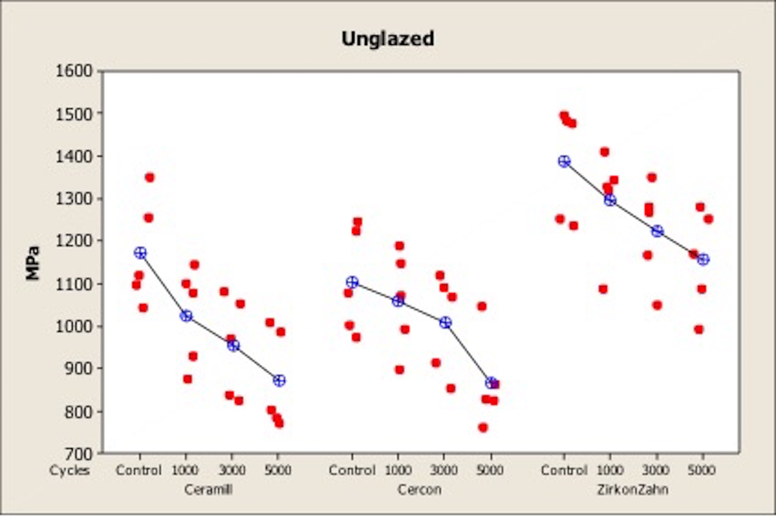

Fig 2b. Dot plot figure demonstrating the distribution of biaxial flexural strength values (MPa) around the mean value for the unglazed zirconia without and with thermal cycling.

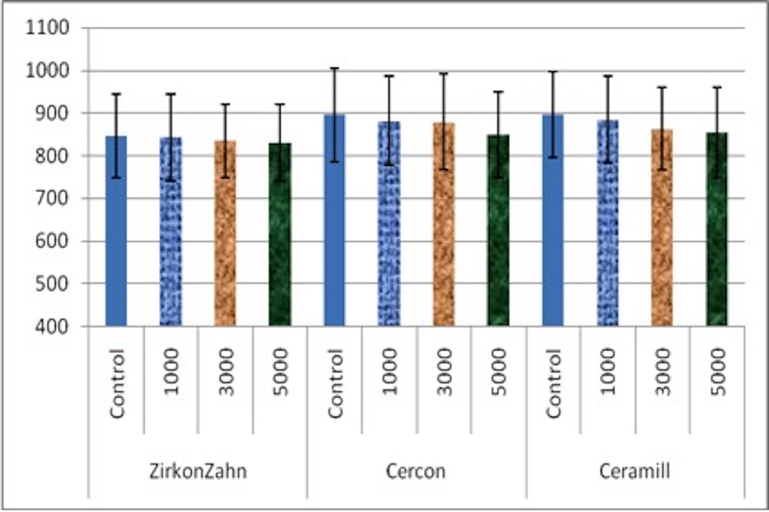

Fig 3a. The mean biaxial flexural strength values (MPa) for glazed zirconia systems without and with thermal cycling.

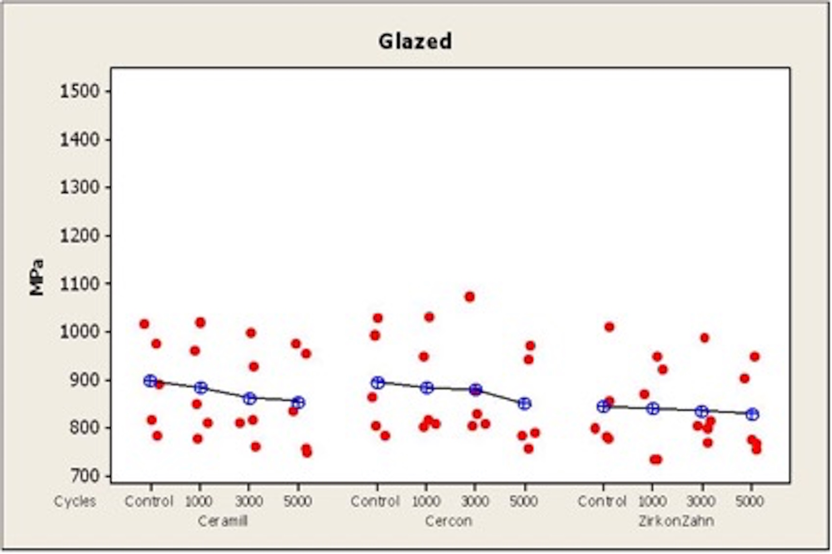

Fig 3b. Dot plot figure demonstrating the distribution of biaxial flexural strength values (MPa) around the mean value for the glazed zirconia without and with thermal cycling.

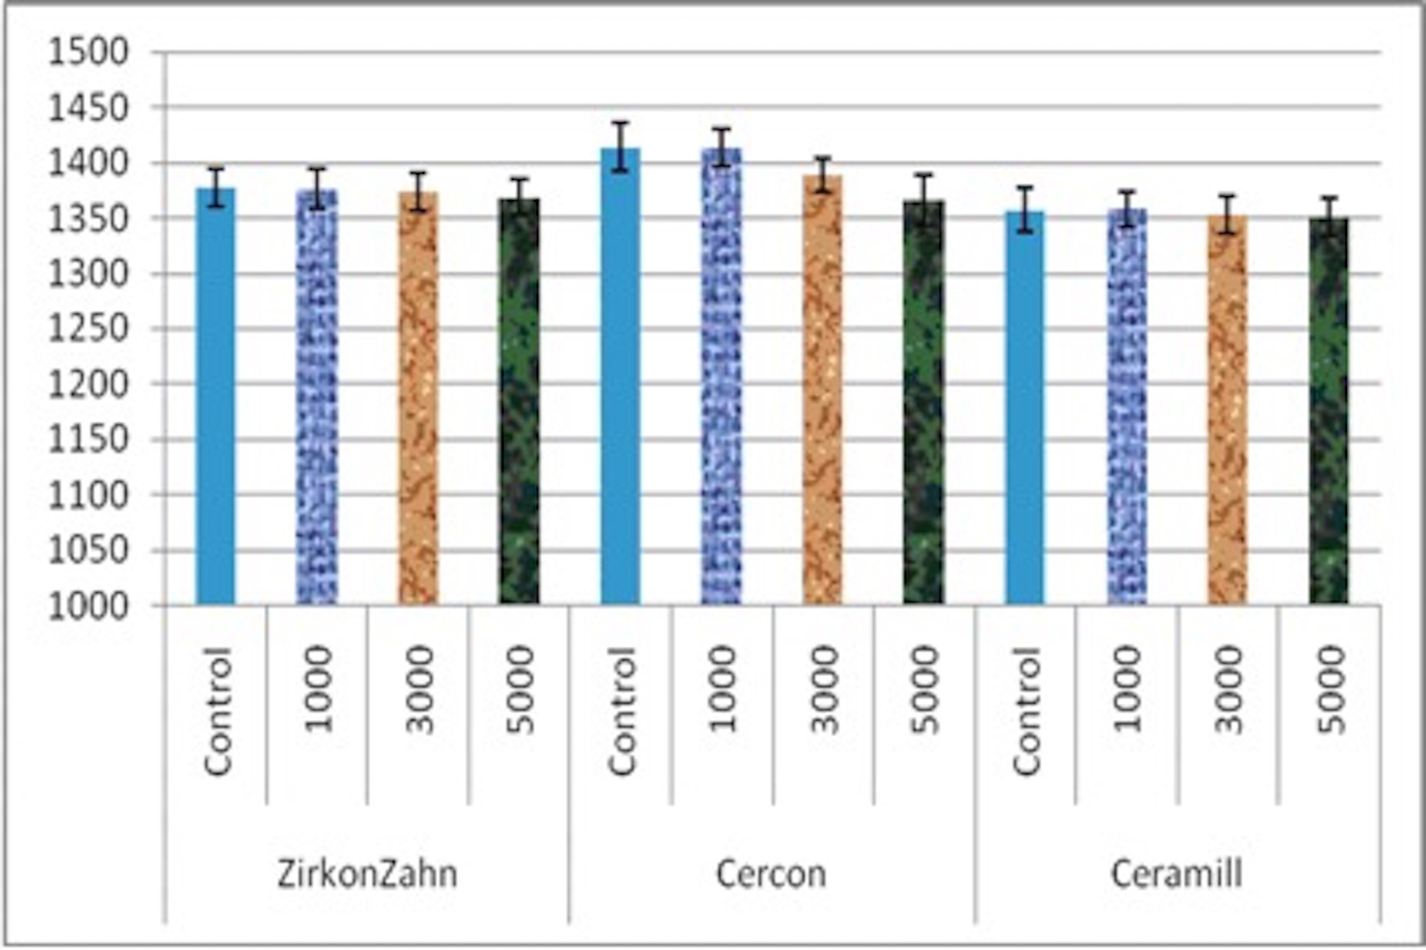
Fig 4. The mean Vickers hardness values (VHN) for unglazed glazed zirconia systems without and with thermal cycling.

