Copyright Notice
COPYRIGHT TRANSFER AND RESPONSIBILITY STATEMENT

All manuscript's copyright ownership of the article “Esthetic and functional rehabilitation with Alumina: a case report" is transferred from the author(s) to the BRAZILIAN DENTAL SCIENCE, in the event the work is published. The manuscript has not been published elsewhere and that it has not been submitted simultaneously for publication elsewhere.
We hereby attest the study is original and does not present manipulated data, fraud or plagiarism. We made significant scientific contribution to the study and we are aware of the presented data and in agreement with the final version of the manuscript. We assume complete responsibility for the ethical aspects of the study.
04/06//2016
Authors

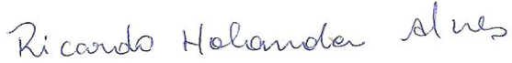
____________________________
Ricardo Holanda Alves

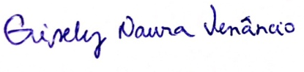
____________________________
Gisely Naura Venâncio

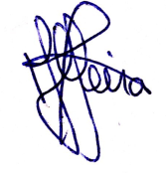

____________________________
Joyce de Figueiredo Meira

____________________________
Carina Toda
_____________________________
Nikeila Chacon de Oliveira Conde

____________________________
Maria Fulgência Costa Lima Bandeira

