COPYRIGHT TRANSFER AND RESPONSIBILITY STATEMENT

All manuscript's copyright ownership of the article "Dry needling the masseter muscle in the treatment of myofascial pain: case reports" is transferred from the author(s) to the BRAZILIAN DENTAL SCIENCE, in the event the work is published. The manuscript has not been published elsewhere and that it has not been submitted simultaneously for publication elsewhere.
We hereby attest the study is original and does not present manipulated data, fraud or plagiarism. We made significant scientific contribution to the study and we are aware of the presented data and in agreement with the final version of the manuscript. We assume complete responsibility for the ethical aspects of the study.
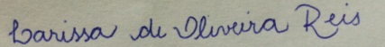

Larissa de Oliveira Reis
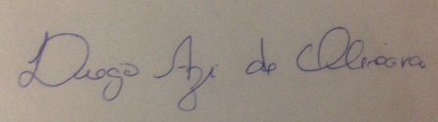

Diego Azi de Oliveira
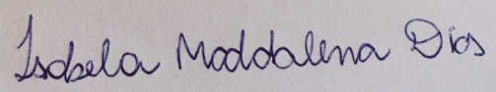

Isabela Maddalena Dias

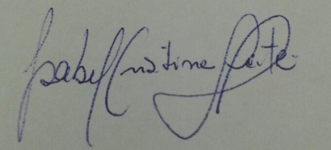
Isabel Cristina Gonçalves Leite
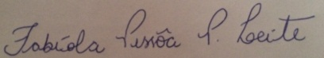

Fabíola Pessôa Pereira Leite
Juiz de Fora, Minas Gerais, 05/09/2016.

