September 29th, 2016

To Whom It May Concern,

This is to declare that I, Christopher James Quinn, a professional Native Canadian English teacher, editor, and translator for English Consulting Brazil, have reviewed and edited the article submitted for publication in your journal entitled “Biomechanical tools to study dental implants: A literature review” for structure, grammar, punctuation, spelling, word choice, and readability. If you have any questions, concerns, or doubts regarding the review/editing, please contact me at: englishconsultingbrazil@gmail.com.

Thank you and kind regards,

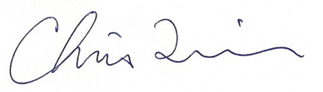_______________________________

Christopher J. Quinn
Teacher, Editor, Portuguese to English Translator, English Consultant
ECB – English Consulting Brazil
Natal, RN, Brazil

