New fabrication method using additive manufacturing technologies for the pattern of a pressed lithium disilicate onlay restorations.

ABSTRACT
A technique for a pressed lithium disilicate onlay restoration using an additive manufactured castable printed pattern is described. The digital workflow allows a complete digital processing of the restoration, from the digital impression with an intraoral scanner to the 3D printed pattern to obtained the final restoration.

KEYWORDS
3D printing, Additive Manufacturing Technologies, Lithium Disilicate Pressed Onlay Restorations.

INTRODUCTION
Additive manufacturing (AM) technologies are the computer aided manufacturing technologies (CAM) that consist on the fabrication of an object layer-by-layer building up process.¹ The rapid evolution of the market has position the 3D printing applications on the edge of the latest technologies; although in dentistry, fairly small applications are available, analysed, validated and systematically used on our daily basic clinical procedures. Because of its immaturity, the fundamental limitation is based on the restricted variety of biocompatible 3D printed materials approved for dental applications by recognized organizations.
One of the available materials for AM applications is the possibility to print castable patterns that can be process through conventional procedures and thus, obtained dental restorations²⁻⁴. The first dental case report for this AM technology was the fabrication of the 3D pattern of the framework for a removable partial denture fabrication.⁵⁻⁷
Following the process thinking, the 3D printed AM pattern fabrication for a pressed lithium disilicate onlay restoration can be achieved. Clinical studies have already identified that the longevity of indirect ceramic restorations is dependent on many different factors like material, patient, dentist and technique. However, and thanks to improvements in all-ceramic materials properties, adhesion techniques and fabrication technologies, these conservative restorations are a clinically acceptable and recognized alternative for large cavities.⁸⁻¹⁷
The present article describes a technique that uses the AM technologies to fabricate the pattern of the pressed lithium disilicate onlay restoration.

TECHNIQUE
A 38 years old male presented with the chief complain “I have a tooth broken”. The patient presented a healthy oral conditions. In the intraoral examination, an ocluso-distal composite restoration with the fracture of the disto-lingual cusp on the right first mandibular molar was observed (Figure 1A-C). The diagnostic x-ray showed a root canal treatment (RCT) done with a periapical radiolucency lesion and a deep interproximal restoration (Figure 2).
In order to evaluate the remaining tooth structure, the removal of the composite restoration was done. The disto-lingual cusp and the distal marginal border of the tooth were missing, however the disto-buccal, mesio-buccal and mesio-lingual cusps presented enough thickness and dentine support to avoid the cuspal coverage with the planned restoration. Furthermore, the gingival floor of the cavity was located at the level of the bone crest, so a crown lengthening was indicated in order to restore the tooth in a predictable way;¹⁸⁻²⁰ as well as, the retreatment of the RCT was indicated. Both procedures were executed by private specialists (Figure 3, 4).
After the complete healing, the reconstruction of the tooth with a pressed lithium disilicate onlay restoration was done as follows.
- At the first clinical appointment, build up the tooth with a composite resin restoration (Filtek Supreme XTE A3D, 3M ESPE, Diegem, Belgium) as needed in order to seal the endodontic treatment and provide enough composite support to weak cusps that don’t present dentin support.
- Prepare the cavity for an onlay restoration: Locate the gingival floor of the preparation 0.5-1 mm above the gingival margin, with a 1 mm width; a 2 mm isthmus reduction with an expulsive shape and make sure that there is enough interocclusal space for the restorative material of 1,5 mm. Do not leave sharp internal angles. Use a round-ended tapered diamond bur (8845KR.314.021 and 845KR.314.021, Komet, USA) under continuous water cooling. Locate the margin of the preparation outside the contact point with the antagonist (Figure 5). The preparation of the onlay restoration will depend on each clinical case.
- Make a digital impression: Scan the tooth preparation, the maxillary and mandibular arch and patient´s occlusion with an optical intraoral scanner (TRIOS, 3Shape, Brussels, Denmark) following the manufacturer’s instructions.
- Prepare a provisional restoration with a light-cured provisional material (FermitTM N, Ivoclar Vivadent, Schaan, Liechtenstein).
- For the laboratory procedures, use a specific CAD software (3Shape software, 3Shape, Brussels, Denmark) to design the onlay restoration. Obtain the STL file of the digital onlay restoration (Figure 6AB). The onlay design can also be executed by a CAD specialized dental technician in a dental laboratory.
- Using the STL file, obtain a wax-up castable onlay restoration pattern (Visijet M3 DentCast, 3D Systems, Budel, Netherlands) with a multijet printer (Projet MJP 3600 Dental, 3D systems, Budel, Netherlands) (Figure 7). The manufacturing of the pattern can be provided by a specialized dental laboratory in additive manufacturing technologies.
- Press the 3D printed AM castable pattern to obtained the lithium disilicate onlay restoration:
- Sprue the printed pattern by attaching a 10 ga. lead to the lingual surface of the rest. Following the instructions of the manufacturer, the recommended length of the wax wire is 3-8 mm and 15-16 mm including the wax-up pattern, the angle between the ring base and the sprue should be between 45-60 degrees (Figure 8AB).
- Invest with a specific investment (IPS PressVEST, Ivoclar, Schaan, Liechtenstein) following the manufacture’s recommendations for powder/liquid ratio under vacuum mixture, mixing time and setting time.
- Burn out at temperature of 1560°F (850°C) for one hour.
- Press the lithium disilicate ingot (LT A2 IPS Emax.Press, Ivoclar Vivadent, Schaan, Liechtenstein), following the manufacture’s indications.
- Divest after cooling to room temperature (approximately 60 minutes) using a diamond disc to separate the alox plunger to the investment ring. Do the rough divestment with glass beads at 4 bar (60 psi) pressure and fine divestment with a reduced pressure of 2 bar (30 psi).
- Pour the restoration on 5% hydrofluoric acid (Invex Liquid IPS emax.Press, Ivoclar Vivadent, Schaan, Liechtenstein) placed on a plastic cup for 15 minutes, and remove the reaction layer with 100 Al₂O₃ at 1-2 bar (15-30 psi) pressure.
- Remove the sprue using a diamond bur and polished under water refrigeration. Polish the restoration (Figure 9AB).
- At the second clinical appointment, deliver the restoration with a dual-cure (Rely-X Lava Ultimate, 3M ESPE, Diegem, Belgium) resin composite cement following the manufacturer’s instructions with an absolute isolation of the field with rubber dam (Figure 9CD).

DISSCUSION
The 3D printing additive manufacturing technology is a current option to fabricate castable patterns. AM technologies are more economical as it does not waste material, because the unused material can be process in the future²¹⁻²³ and no tooling is needed.^{23,24} Furthermore, 3D printing allows to print more than one pattern at a time, the number of patterns will depend on the size of the patterns and the size of the building platform. The applications of AM technologies will be developed at the same time that the variety of printed materials increases on the market.
AM technologies present a free complexity on the printed objects, while on our current gold standard ¨milling procedures¨ the access and tool size limits the desired final shape of the fabricated object^{2,3,24-26}. It may be reasonable to argue, that AM are more capable to reproduce a more detailed occlusal anatomy of a printed pattern, and so it will be extended to the pressed lithium disilicate restoration. However, a more in vitro and clinical studies need to be carried out to analyse further the dental applications of AM technologies.

SUMMARY

A technique description to fabricate a 3D printed additive manufactured castable pattern for a lithium disilicate restoration is described. The clinical procedures are similar than the conventional handmade wax-up or milled patterns, however the main advantage of the additive manufacturing technologies are the capability to recreate a more complex anatomy and shapes.

REFERENCES
- ASTM, Committee F42 on Additive Manufacturing Technologies, West Conshohocken, Pa. 2009.
- Azari A, Nikzad S. The evolution of rapid prototyping in dentistry: a review. Rapid Prototyping J 2009;15:216-225.
- Sun J, Zhang FQ. The Application of Rapid Prototyping in Prosthodontics. J Prosthodont 2012;21:641.
- Cho SH, Chang WG. Mirror-image anterior crown fabrication with computer-aided design and rapid prototyping technology: A clinical report. J Prosthet Dent 2013;109:75-78.
- Williams RJ, Bibb R, Rafik T: A technique for fabricating patterns for removable partial denture frameworks using digitized casts and electronic surveying. J Prosthet Dent 2004;91:85-88.
- Wu M, Tinschert J, Augthun M, et al. Application of laser measuring, numerical simulation and rapid prototyping to titanium dental castings. Dent Mater 2001;17:102-108.
- Williams RJ, Bibb R, Eggbeer D, et al. Use of CAD/CAM technology to fabricate a removable partial denture framework. J Prosthet Dent 2006;96:96-99.
- Beier US, Kapfarer I, Burtscher D, et al. Clinical performance of all ceramic inlay and onlay restorations in posterior teeth. Int J Prosthodont 2012;25:395-402.
- Boushell LW, Ritter AV. Ceramic inlays: a case presentation and lessons learned from the literature. J Esthet Restor Dent 2009; 21:77-87.
- Thordrup M, Isidor F, Hörsted-Bindslev P. A prospective clinical study of indirect and direct composite and ceramic inlay: ten-year results. Quintessece Int 2006;37:139-144.
- Fuzzi M, Rappelli G. Ceramic inlays: Clinical assessment and survival rate. J Adhes Dent 1999;1:71-79.
- Naeselius K, Arnelund CF, Molin MK. Clinical evaluation of all-ceramic onlays: a 4-year retrospective study. Int J Prosthodont 2008;20:40-44.
- Beier US, Kapferer I, Dumfahrt H. Clinical long-term evaluation and failure characteristics of 1,335 all-ceramic restorations. Int J Prosthodont 2012;25:70-78.
- Beier US, Dumfahrt H. Longevity of silicate ceramic restorations. Quintessence Int 2014;45:637-644.
- Molin MK, Karlsson SL. A randomized 5-year clinical evaluation of 3 ceramic inlay systems. Int J Prosthodont 2000;13:194-200.
- Fabbri G, Zarone F, Dellificorelli G, et al. Clinical evaluation of 860 anterior and posterior lithium disilicate restorations: retrospective study with a mean follow-up of 3 years and a maximum observational period of 6 years. Int J Periodontics Restorative Dent 2014;34:165-177.
- Kois DE1, Isvilanonda V, Chaiyabutr Y, et al. Evaluation of fracture resistance and failure risks of posterior partial coverage restorations. J Esthet Restor Dent 2013;25:110-122.
- Palomo F, Kopczyk RA. Rationale and methods for crown lengthening. J Am Dent Assoc. 1978 Feb;96(2):257-260.
- Brägger U, Lauchenauer D, Lang NP. Surgical lengthening of the clinical crown. J Clin Periodontol. 1992 Jan;19(1):58-63.
- Ribeiro FV1, Hirata DY, Reis AF, et al. Open-flap versus flapless esthetic crown lengthening: 12-month clinical outcomes of a randomized controlled clinical trial. J Periodontol. 2014 Apr;85(4):536-544.
- Berman B. 3D printing: The new industrial revolution. Bus Horiz 2012;55:155-157.
- Van Noort R. The future of dental devices is digital. Dent Mater 2012;28:3-12.
- Stansbury JW, Idacavage MJ. 3D printing with polymers: Challenges among expanding options and opportunities. Dent Mater 2016;32:54-64.
- Abduo J, Lyons K, Bennamoun M. Trends in computer-aided manufacturing in prosthodontics: a review of the available streams. Int J Dent 2014;2014:1-15.
- Torabi K, Farjood E, Hamedani S. Rapid Prototyping Technologies and their Applications in Prosthodontics, a Review of Literature. J Dent Shiraz Univ Med Sci 2015;16:1-9.
- Braian M, Jimbo R, Wennerberg A. Production tolerance of additive manufactured polymeric objects for clinical applications. Dent Mater 2016;32:853-861.

Legends for figures:

Figures:
Figures 1a-c. A) Occlusal view of the patient´s mouth, with a cusp fracture on the right first mandibular molar; B) Lingual view; and C) Bucal view of the clinical situation.
Figure 2. Diagnosis radiographical evaluation of the first right mandibular molar.
Figure 3. Crown lengthening procedure was carried out to re-establish the biological width.
Figure 4. Radiographical evaluation after the re-treatment of the RCT and the crown lengthening was done.
Figure 5. Occlusal view of the onlay preparation made.
Figures 6a-b. A) Occlusal view and; B) Intaglio surface of the digital design (STL File image) of the onlay restoration.
Figures 7a-c. A) Castable 3D printed pattern of the onlay restoration; detailed of B) the occlusal and C) the intaglio surface of the onlay printed pattern.
Figures 8a-c. A) Sprued of the 3D printed AM castable pattern; B) and C) Detailed.
Figures 9a-d. A) Pressed lithium disilicate restoration fabricated and polished; B) Detailed of the occlusal and the intaglio surface of the restoration; C) Onlay restoration cemented; D) Radiographic with the lithium disilicate onlay delivered.

Figures:

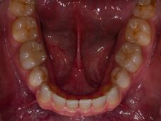 A)
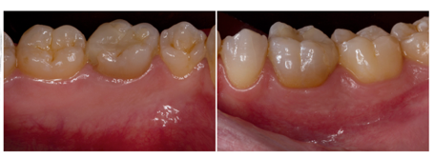
B) C)
Figures 1a-c. Intraoral occlusal view of a) maxilla with seven implants, b) mandible with six implants and two provisional implants to increase the retention of interim mandibular complete denture, c) Initial panoramic x-ray.
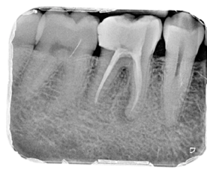
Figure 2. Diagnosis radiographical evaluation of the first right mandibular molar.

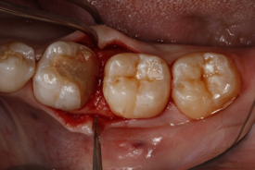

Figure 3. Crown lengthening procedure was carried out to re-establish the biological width.

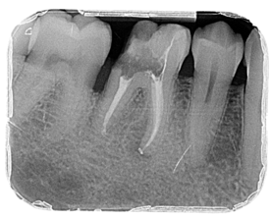

Figure 4. Radiographical evaluation after the re-treatment of the RCT and the crown lengthening was done.

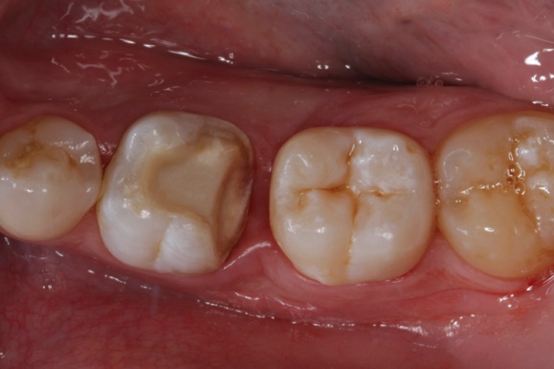

Figure 5. Occlusal view of the onlay preparation made.

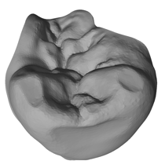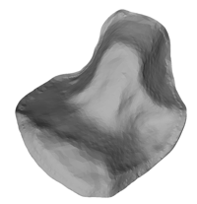
- B)
Figures 6a-b. A) Occlusal view and; B) Intaglio surface of the digital design (STL File image) of the onlay restoration.

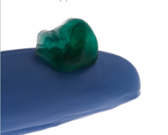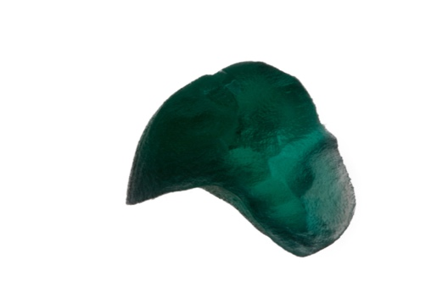
- B)

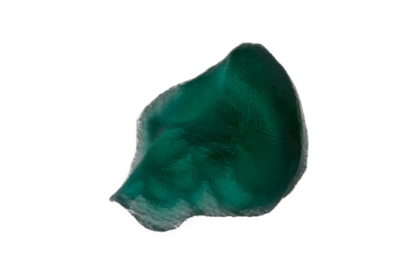
C)

Figures 7a-c. A) Castable 3D printed pattern of the onlay restoration; detailed of B) the occlusal and C) the intaglio surface of the onlay printed pattern.

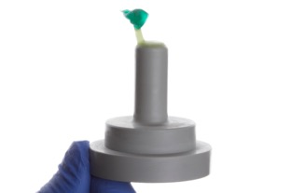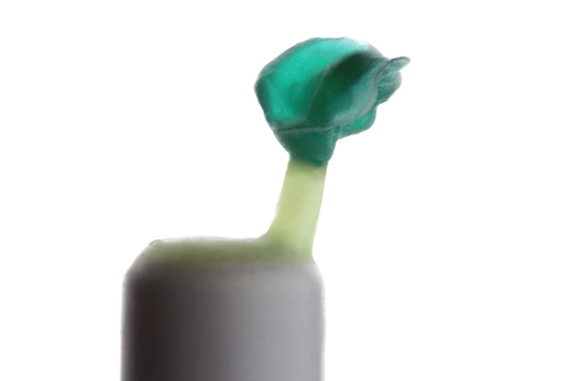
A) B)
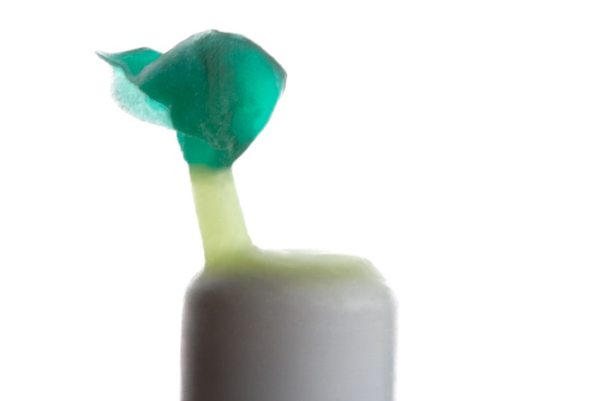 C)
Figures 8a-c. A) Sprued of the 3D printed AM castable pattern; B) and C) Detailed.

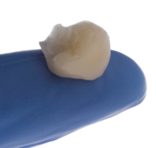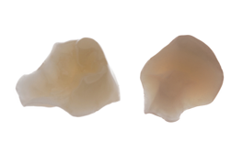
- B)
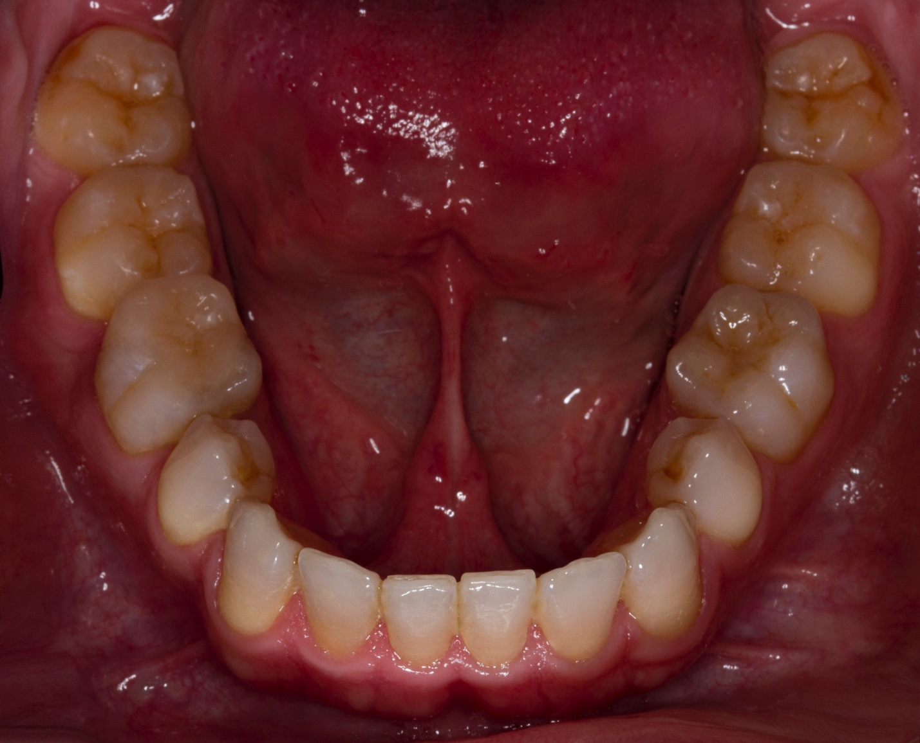 C)
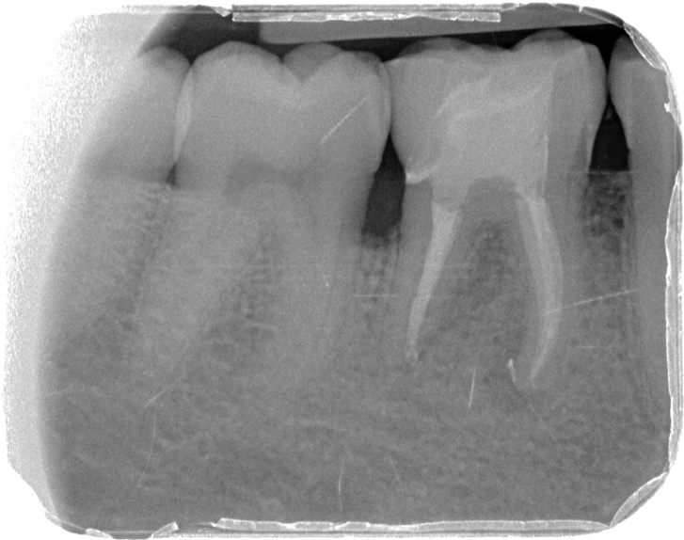 D)

Figures 9a-d. A) Pressed lithium disilicate restoration fabricated and polished; B) Detailed of the occlusal and the intaglio surface of the restoration; C) Onlay restoration cemented; D) Radiographic with the lithium disilicate onlay delivered.

