COPYRIGHT TRANSFER AND RESPONSIBILITY STATEMENT

All manuscript's copyright ownership of the article " Resin push-out bonding strength to root canal dentin: effect of the irrigation solution application prior to post cementation " is transferred from the author(s) to the BRAZILIAN DENTAL SCIENCE, in the event the work is published. The manuscript has not been published elsewhere and that it has not been submitted simultaneously for publication elsewhere.
We hereby attest the study is original and does not present manipulated data, fraud or plagiarism. We made significant scientific contribution to the study and we are aware of the presented data and in agreement with the final version of the manuscript. We assume complete responsibility for the ethical aspects of the study.

Name: Silvia M. A. Michida
Address Av. Engenheiro Francisco José Longo, 777. Jardim São Dimas, São José dos Campos, SP. Brazil. CEP: 12245000_ __________________________
Email 1___silviamasae@yahoo.com.br___________ Email 2____________________________________
Signature___________________________________ Date_______________________________________

Name: Amanda Maria de Oliveira Dal Piva
Address Av. Engenheiro Francisco José Longo, 777. Jardim São Dimas, São José dos Campos, SP. Brazil. CEP: 12245000_ __________________________
Email 1_amanda.piva@ict.unesp.br______________ Email 2___dalpiva.amanda@yahoo.com.br________
Signature___________________________________ Date_______________________________________

Name: João Paulo Mendes Tribst
Address Av. Engenheiro Francisco José Longo, 777. Jardim São Dimas, São José dos Campos, SP. Brazil. CEP: 12245000_ __________________________
Email 1___joao.tribst@ict.unesp.br_____________ Email 2____________________________________
Signature___________________________________ Date_______________________________________

Name: Rodrigo Othávio de Assunção e Souza
Address: Av. Salgado filho, 1787, Lagoa Nova, Natal/RN, Brazil, Zip Code: 59.056-000
Email 1 roasouza@yahoo.com.br_ Email 2____________________________________
Signature___________________________________ Date_______________________________________

Name: Geraldo H. L. Lombardo
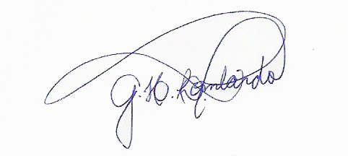
Address Av. Engenheiro Francisco José Longo, 777. Jardim São Dimas, São José dos Campos, SP. Brazil. CEP: 12245000_ __________________________
Email 1__geraldolombardo@hotmail.com________ Email 2____________________________________
Signature___________________________________ Date_______________________________________

Name: Marco Antonio Bottino
Address Av. Engenheiro Francisco José Longo, 777. Jardim São Dimas, São José dos Campos, SP. Brazil. CEP: 12245000_ __________________________
Email 1 mmbottino@uol.com.br Email 2____________________________________
Signature___________________________________ Date_______________________________________

Name: Luiz Felipe Valandro
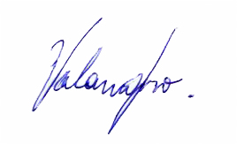
Address Av. Engenheiro Francisco José Longo, 777. Jardim São Dimas, São José dos Campos, SP. Brazil. CEP: 12245000_ __________________________
Email 1__lfvalandro@gmail.com_________________ Email 2____________________________________
Signature_________________ __________________ Date_______________________________________

