Faculdade de Odontologia E INSTITUTO DE PESQUISAS SÃO LEOPOLDO MANDIC

Faculdade de Odontologia e Instituto de Pesquisas São Leopoldo Mandic
Depto de Odontologia Restauradora - Dentística
Rua José Rocha Junqueira, 13
CEP: 13045-755 - Campinas – SP
BRAZIL

August 25th, 2017.
Prof. Dr. Sérgio Eduardo de Paiva Gonçalves, Editor-in-Chief
Brazilian Dental Science

Dear Editor,
We are submitting our original research report entitled “Chitosan in different concentrations added to a two-step etch-and-rinse adhesive system: influence on bond strength to dentin” to be examined by the scientific referees appraisal.
We would like to certify that article was exclusively submitted to Brazilian Dental Science and that it is not concurrently under consideration for publication in another journal. All the named authors involved in the paper had read it before its submission to publication and confirmed the approval of the complete content. The authors have no financial, economic, commercial, and/or professional interests related to topics presented in the manuscript.
Suggested reviewers:
Profa. Dr. Linda Wang - wang.linda@uol.com.br
Prof. Dr. Flávio Baggio Aguiar - baggioaguiar@yahoo.com.br;aguiar@fop.unicamp.br

Thank you in advance for your kind attention.
Sincerely,
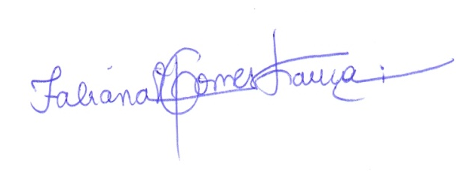
__________________________ 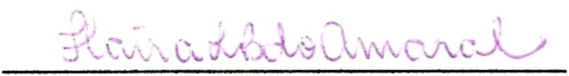
Fabiana Mantovani Gomes França Flávia Lucisano Botelho do Amaral
____________________________ ______________________________
Cecilia Pedroso Turssi Roberta Tarkany Basting

