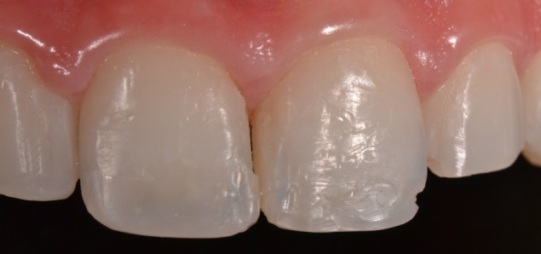
Figure 2 – Fractured restorations in teeth #11 and #21.

