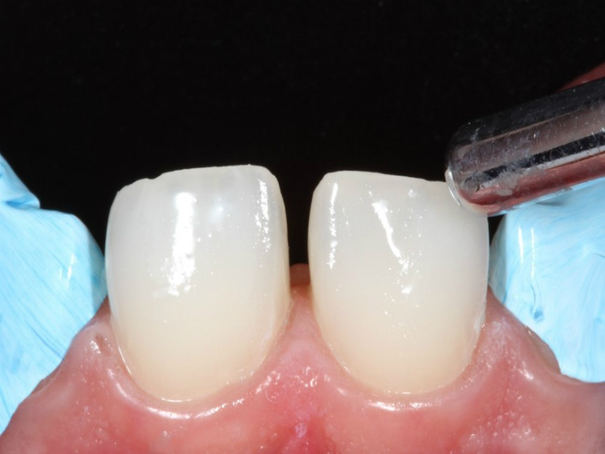 Figure 8 – removal of the excesses of the adhesive with air jet.