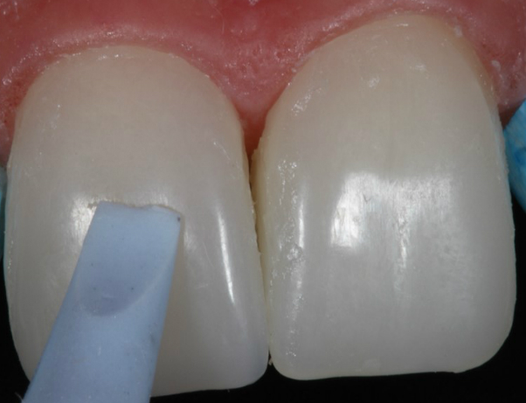
Figure 10 –Placement of the veneers on the teeth with a silicone spatula.

