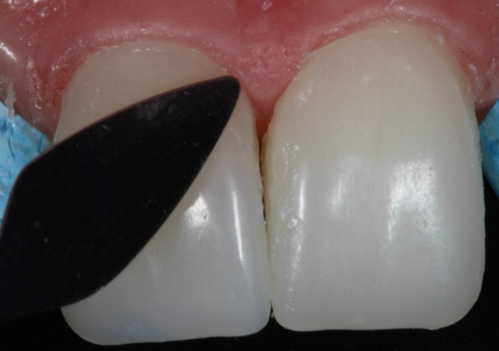
Figure 11 – Removal of the excess of composite resin

