Araçatuba, December 14th, 2017.

Sergio Eduardo de Paiva Gonçalves
São Paulo State University (Unesp), Institute of Science and Technology
São José dos Campos, SP, Brazil
Editor-in-Chief
Brazilian Dental Science,

I, along with my coauthors, would like to ask you to consider the attached original manuscript entitled “Vascular permeability assay and hydrogen peroxide concentration in bleaching gels with desensitizing agents”, for publication in the Brazilian Dental Science.

We believe that the findings of this study are relevant to the scope of your journal and will be of interest to its readership.

This manuscript has not been published or presented elsewhere in part or in entirely, and is not under consideration by another journal. All the authors have approved the manuscript and agree with submission to your esteemed Journal.

There are no conflicts of interest to declare.

Sincerely,
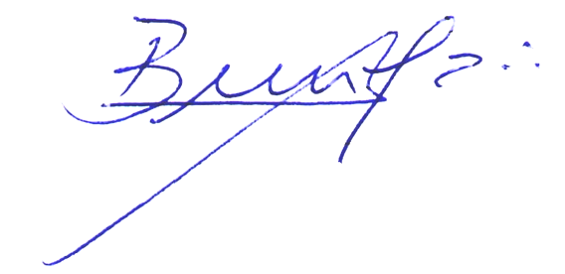

___________________________________________
DDS, PhD, Associate Professor André Luiz Fraga Briso

