Copyright Notice

**COPYRIGHT TRANSFER AND RESPONSIBILITY STATEMENT**

All manuscript's copyright ownership of the article "***Interaction between photoactivators and modeling adhesives on the degree of conversion of a composite for bleached teeth***" is transferred from the author(s) to the BRAZILIAN DENTAL SCIENCE, in the event the work is published. The manuscript has not been published elsewhere and that it has not been submitted simultaneously for publication elsewhere.

We hereby attest the study is original and does not present manipulated data, fraud or plagiarism. We made significant scientific contribution to the study and we are aware of the presented data and in agreement with the final version of the manuscript. We assume complete responsibility for the ethical aspects of the study.

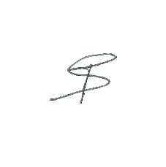Authors:

*Thiago Jonathan Silva dos Santos*

*Ana Margarida dos Santos Melo*

*Matheus Dantas Tertulino*

*Boniek Castillo Dutra Borges*

*Ademir Oliveira da Silva*

*Maria Cristina dos Santos Medeiros*

Signature (1): _____________________

Signature (2): _____________________

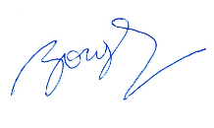Signature (3): _____________________

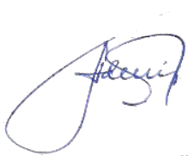Signature (4): _____________________

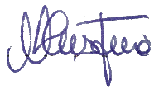Signature (5): _____________________

Signature (6): _____________________

**This text must be printed and signed by all authors. The scanned version should be submitted as supplemental file during the submission process.**