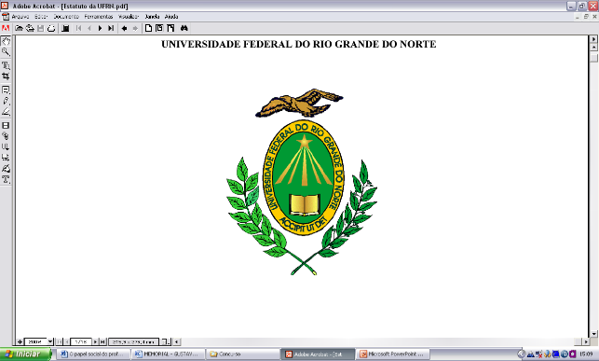

**Federal University of Rio Grande Do Norte**

**Department of Dentistry**

Natal, February 22, 2018

Dear Dr. Sérgio Eduardo de Paiva Gonçalves,

Please consider the research article **“Interaction between photoactivators and modeling adhesives on the degree of conversion of a composite for bleached teeth”** for publication in the ***Brazilian Dental Science***. A limited number of studies have evaluated the effect of the LED light sources used during a restoration using composite resin when submitted to brush lubricants. This study aimed to analyze the effect of two LED light sources on the degree of conversion of composite resin for bleached teeth under the influence of adhesives used as modelers. The results indicated that the use of adhesives as modelers of Empress Direct resin for bleached teeth increases the degree of conversion of the composite surface, and that photoactivation with polywave or monowave LEDs does not interfere with this property.

On behalf of the co-authors,

C:\Users\Ana\Desktop\Assinatura.jpg

Ana Margarida dos Santos Melo, DDS