Figure 1: Area of interest delimitation for surface roughness evaluation.
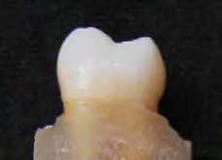
The square inside blue lines delimited the area of interest in the vestibular face of deciduous teeth.

