Figure 2: Column graph (mean ± sd) of roughness values Ra (μm), according to the groups.
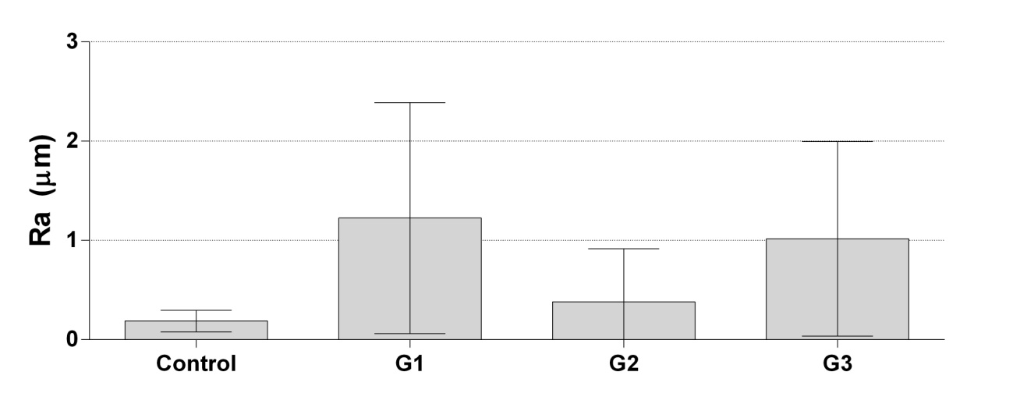
Comparative roughness of deciduous teeth enamel.

