FIGURE
Figure 1: Die in dental stone (a), occlusal and proximal view of pattern in wax (b), specimens in acrylic resin (c) and bis-acrylic (d).
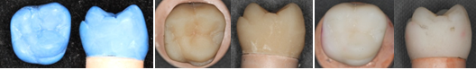
a
d
c
b

