Dear editor,

All manuscript's copyright ownership of the article "Effect of enamel pretreatment on the fluoride remineralization of artificial white spot lesions" is transferred from the author(s) to the BRAZILIAN DENTAL SCIENCE, in the event the work is published. The manuscript has not been published elsewhere and that it has not been submitted simultaneously for publication elsewhere.

We hereby attest the study is original and does not present manipulated data, fraud or plagiarism. We made significant scientific contribution to the study and we are aware of the presented data and in agreement with the final version of the manuscript. We assume complete responsibility for the ethical aspects of the study.

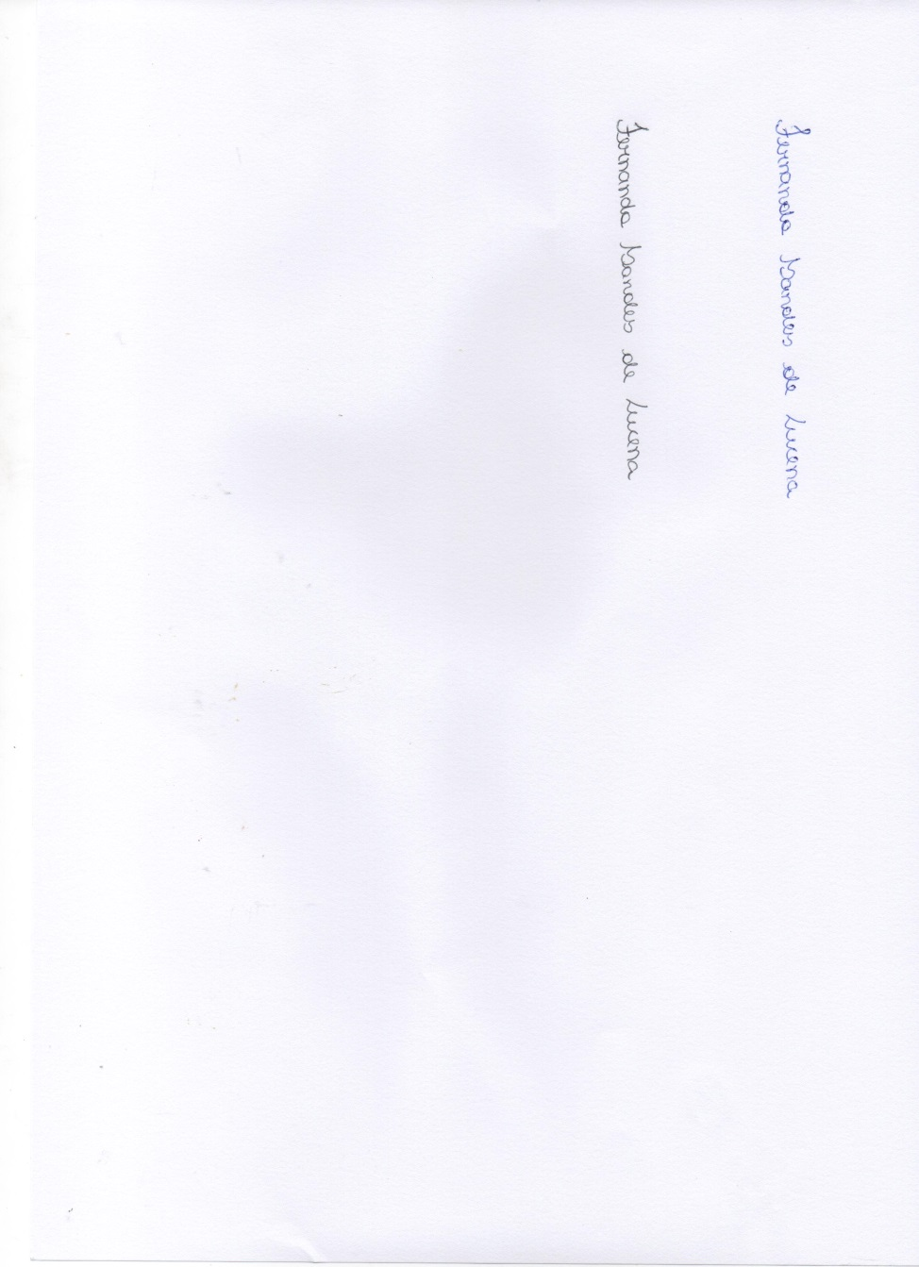



Diana Ferreira Gadelha de Araújo Fernanda Sandes de Lucena

****

Maria Cristina Carvalho de Almendra Freitas Larissa Vasconcellos Nunes

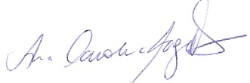

Marília Mattar de Amoêdo Campos Velo Ana Carolina Magalhães



Linda Wang