Captions to the legends and tables
Tables
Table 1 Mean and Standard Deviation (SD) values and results of comparison between bacterial count scores for experimental groups.

Figures
Figure 1. The development E.faecalis biofilm of root canal walls in positive control group; original magnification, 5000x (A) and 10000x (B).
Figure 2. Means and Standard Deviations of the residual bacterial count values after using the different final irrigation agitation techniques.

Figures:

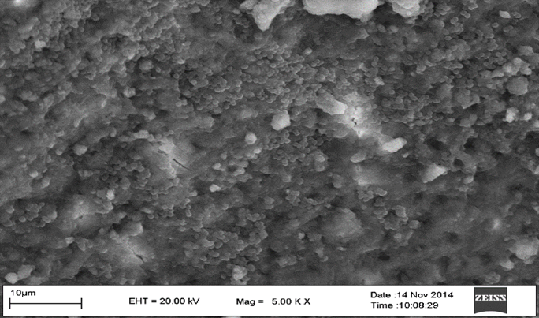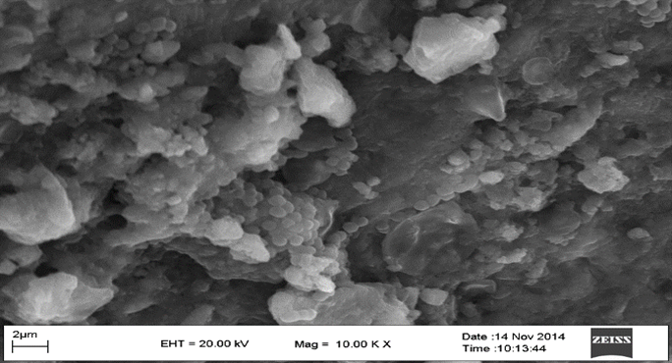
Figure 1. The development E.faecalis biofilm of root canal walls in positive control group; original magnification, 5000x (A) and 10000x (B).
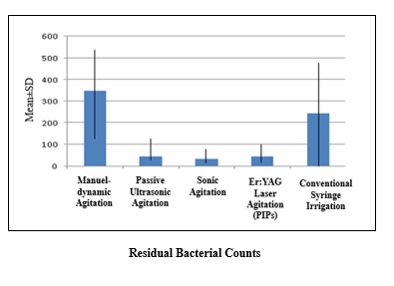
Figure 2. Means and Standard Deviations of the residual bacterial count values after using the different final irrigation agitation technique

