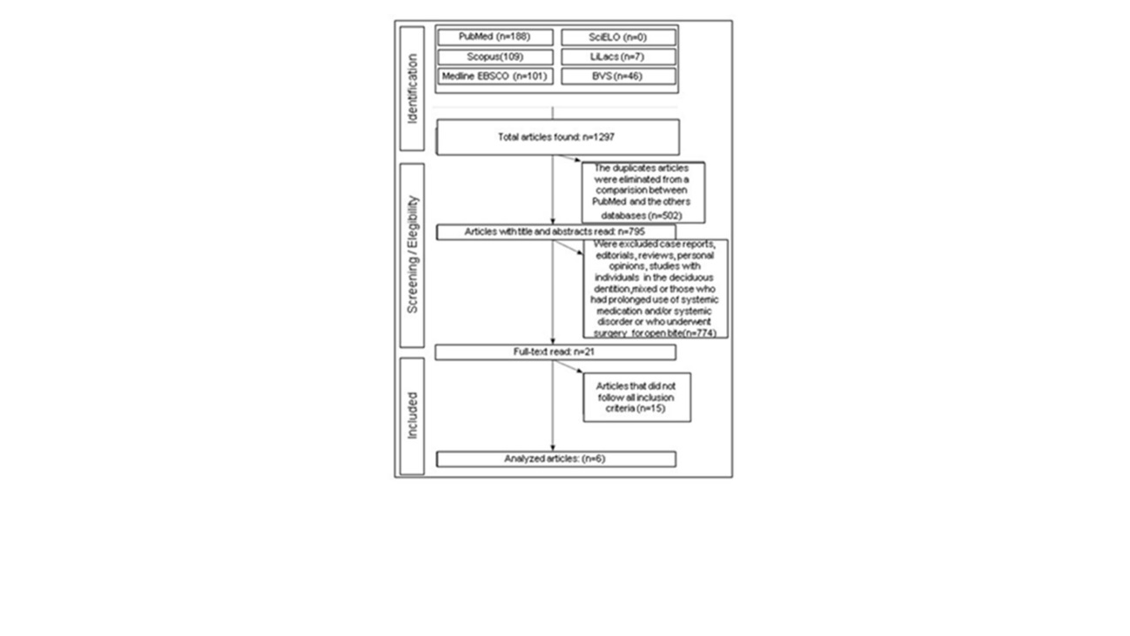
Figure 1: Flowchart: search results.

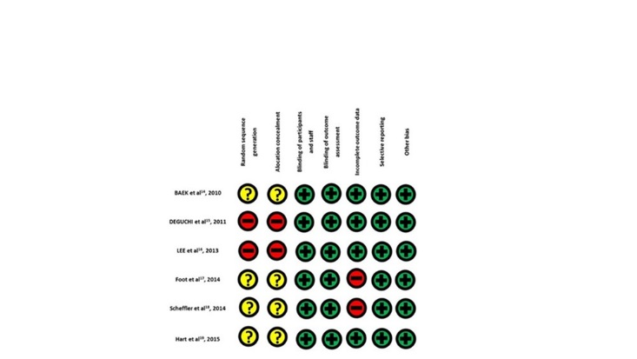
Figure 2: Qualitative evaluation of the selected studies. (Cochrane Collaboration Tool to Assess Bias Risk). Yellow(doubt); Green(presence); Red (absence)

