**Antimicrobial efficacy of Novel Ethanolic Extract of Morinda Citrifolia Against Enterococcus Feacalis by Agar Well Diffusion Method and Minimal Inhibitory Concentration- An Invitro Study.**

**Abstract**

**Introduction**

The long term success of root canal treatment is ultimately related to the effective debridement and disinfection of the root canal system. Hence, the irrigants play an important role in achieving the good penetrability and bactericidal activity. The present study was mainly aimed at evaluating the invitro antimicrobial efficacy of Novel Ethanolic Extract of Morinda Citrifolia by agar well diffusion and minimal inhibitory concentration.

**Materials and Methods:**

The antimicrobial efficacy of the Novel Ethanolic Extract of Morinda Citrifolia was tested using agar well diffusion and minimal inhibitory concentration was assessed. The zone of inhibitions were determined at 10 mg/ml concentration of Ethanolic Extract of Morinda Citrifolia on agar well plate and Minimal Inhibitory Concentration (MIC) against tested microorganism.

**Results:**

Results obtained in the present study by both qualitative and quantitative experiments revieled that the tested Ethanolic Extract of Morinda Citrifolia possesses potential antibacterial activity against Enterococcus Feacalis when compared with standard antibiotic tetracycline. the highest zone of inhibition of 15mm was showed at 1000micrograms by agar well diffusion assay. The optimal antimicrobial activity was seen at 250micrograms for Morinda Citrifolia against Enterococcus Feacalis.

**Conclusion:**

Novel Ethanolic extract of Morinda Citrifolia has shown an optimal antimicrobial activity against E.Feaclais. But still, future studies are still needed.

**Introduction:**

It is impossible for the mechanical instrumentation alone to reach the anatomical complexities such as narrow isthmuses, accessory canals into the dentinal tubules. Hence, the irrigants play an important role in achieving the good penetrability and bactericidal activity to inhibit the micro organisms present in the biofilms and removal of smear layer, inactivate the endotoxins and dissolve the necrotic pulp remnants(1),(2).

The long term success of root canal treatment is ultimately related to the effective debridement and disinfection of the root canal system(3). Chemo-mechanical preparation plays a vital role in achieving successful endodontic therapeutic outcomes. Sodium hypochlorite(NaOCl) is one of the most commonly used root canal irrigant because of its ability to show a broad spectrum antimicrobial activity and its ability to dissolve the necrotic pulp tissue(4). Even though it is the most potent irrigant, it has some adverse characteristics like its tissue toxicity, allergic potential and disagreeable taste. This prompted for the search for alternative irrigants(5).

Literature evidence has shown a wide range of natural plant extracts exhibit antimicrobial property and therapeutic benefits and can be used as root canal irrigants(5),(6),(7),(8),(9),(10). Morinda Citrifolia has been found as a first herbal alternative to sodium hypochlorite as a root canal irrigant. It has a broad range of therapeutic benefits as antibacterial, antiviral, antitumor, anti-helmenthic, antifungal, analgesic, hypotensive, anti-inflammatory and immune enhancing effects(7),(8),(9). The antibacterial activity is mainly by two antibacterial compounds L-aperuloside and alizarin(5).

The present study was mainly aimed at evaluating the invitro antimicrobial efficacy of Novel Ethanolic Extract of Morinda Citrifolia by agar well diffusion and minimal inhibitory concentration.

**Materials and methodology:**

The study was approved by institutional ethical committee. The antimicrobial efficacy of the novel extract was tested using agar well diffusion and minimal inhibitory concentration was assessed.

**Antibacterial activity using Agar well diffusion method**

The samples were screened for antibacterial activity against following Bacterial strain using agar well diffusion method(11),(12),(13),(14).

1. *Enterococcus fecalis*

**Agar well diffusion method**

**Sample Preparation:** 10mg/ml of sample was provided for analysis.

**Procedure:** Luria broth Agar (LBA) plates were inoculated with test organisms. The plates were evenly spread out and a cork borer was used to prepare wells in the plates. Each well was loaded with 20, 40, 60, 80 and 100 µl of corresponding concentration of sample and 10 mg of Tetracycline dissolved in 1 ml of 10% DMSO was used as a positive control. The plates were incubated for 24h at 37°C. The inhibition zone development around the well was measured in diameter and recorded.

**Figure 1 shows antibacterial activity of the samples against *Enterococcus fecalis***

**S1**

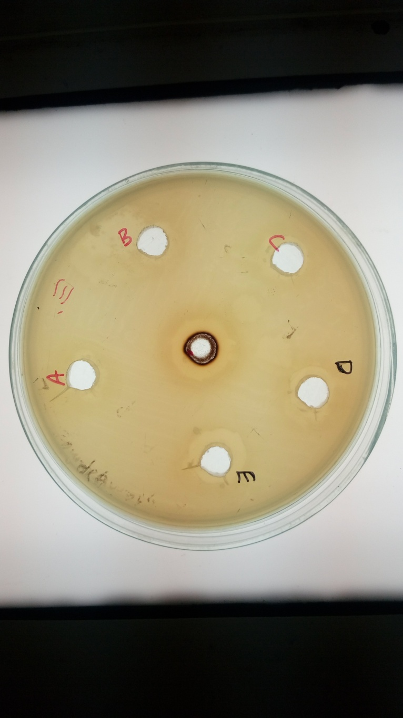

**Minimum Inhibitory concentration (MIC)**

**Sample Preparation:**

10mg of the extract was dissolved in 1ml of ethanol.

**Procedure:**

The sample was subjected to antibacterial activity by micro dilution method against *Entercoccus faecalis.* Luria broth (Himedia, Mumbai) was prepared and then sterilized by autoclaving at 121°C, 15 lbs. for 15 minutes. 96 well micro titre plates were added with 100μl of broth. The given sample was then added in the first well and then serially diluted till the eighth well. Then the 10μl of log phase culture was introduced into the respective wells and Similarly tetracycline (100μl from10mg/ml) was added to 100μl of broth and serially diluted. 10μl of log phase culture that was added, served as the positive control. Broth and culture was taken as Negative control. Sterile broth serves as a control. The entire assembly was incubated at 37°C for 24 hours. The complete growth inhibition at the lowest concentration of the sample determined the MIC.

**Figure 2: shows antibacterial activity of Sample against *Entercoccus faecalis* by using broth micro dilution method.**

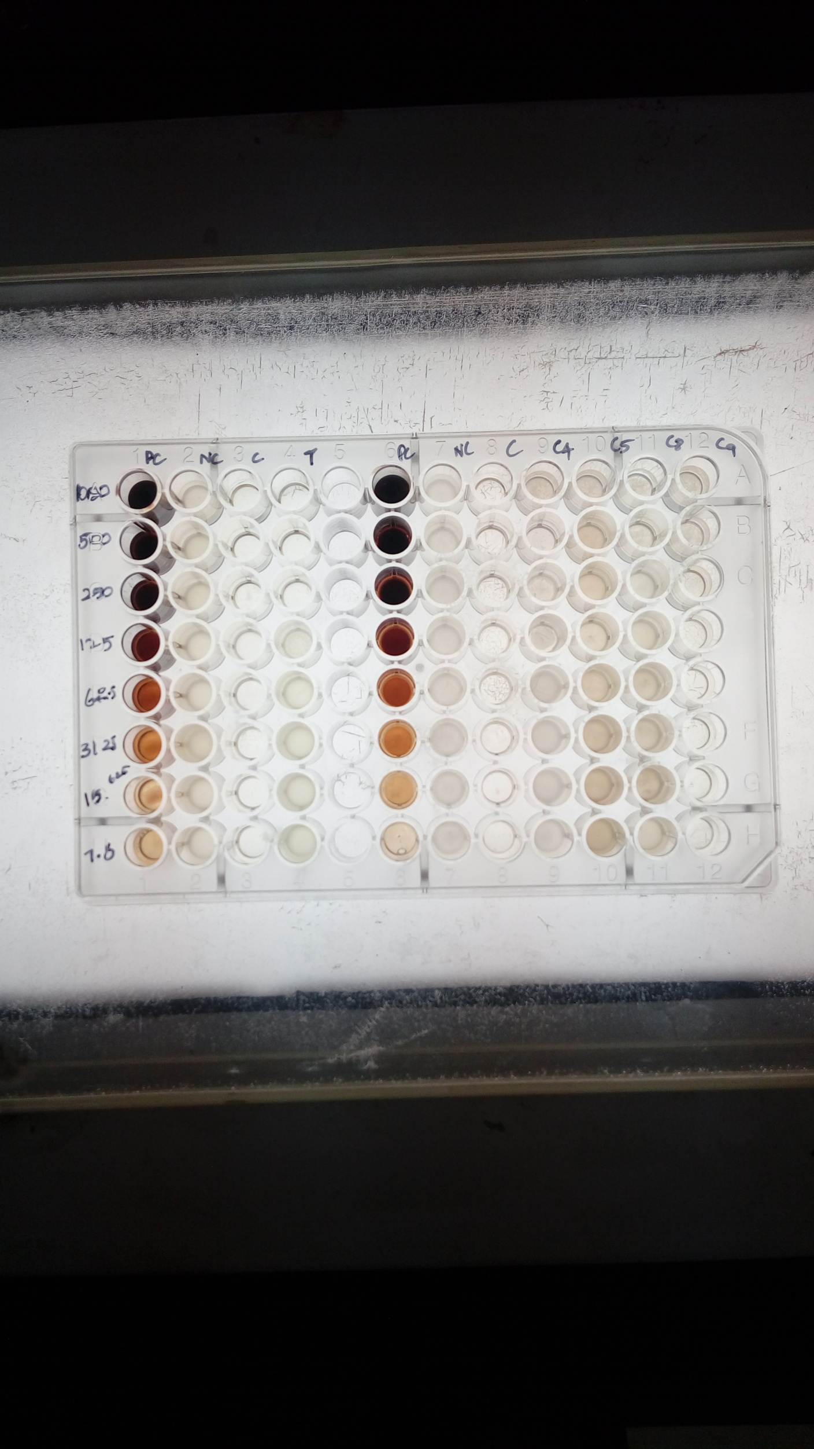

**Concentrations: A-**500μg; **B**-250μg; **C**- 125μg; **D**- 62.5μg; **E**-31.25μg; **F**- 15.625μg; **G**-7.81μg; **H**- 3.9μg

**Results:**

In the present study, the antimicrobial activity of the Ethanolic extract of Morinda Citrifolia was examined, both qualitatively and quantitatively at 10 mg/ml (100μg) concentration by the presence or absence of microbial growth, zone inhibition on agar well test plate. Results obtained in the present study by both qualitative and quantitative experiments relieved that the tested Ethanolic Extract of Morinda Citrifolia possesses potential antibacterial activity against Enterococcus Feacalis. When tested by the disc diffusion method and MIC, the Ethanolic Extract of Morinda Citrifolia showed significant activity against E. Feacalis when compared with standard antibiotic tetracycline(table 1 and 2).

The antimicrobial activity of the Ethanolic Extract of Morinda Citrifolia against E.Feacalis .The result from the antimicrobial well diffusion method summarized in the above table. The control tetracycline showed zone of inhibition of 29mm at the concentration of 400micrograms. Where as the Ethanolic extract Morinda Citrifolia showed no zone of inhibition at 200micrograms, at 400micrograms, it showed 10mm of inhibition, at 600micrograms, 11mm, at 800micrograms, 13mm and the highest zone of inhibition of 15mm was showed at 1000micrograms by agar well diffusion assay.

According to table, the minimum inhibitory concentration (MIC) revealed that the 10 mg/ml of Ethanolic Extract of Morinda Citrifolia was shown average antimicrobial activity against E.Feacalis. The MIC values were tested at 3.9μg, 7.81μg, 15.625μg, 31.25μg, 62.5μg, 125μg, 250μg, 500μg respectively. The optimal antimicrobial activity was seen at 250micrograms for Morinda Citrifolia against Enterococcus Feacalis.

**Table 1 shows Antibacterial activity of samples against *Enterococcus fecalis***

|  |  |  |  |
| --- | --- | --- | --- |
| **Sample** | **Concentration (µg)** | **Zone of inhibition (mm)** | |
| **Sample** | **Control (400 µg)** |
| **S1** | 200 | - | 29 |
| 400 | 10 |
| 600 | 11 |
| 800 | 13 |
| 1000 | 15 |

**Table 2: shows antibacterial activity of samples against*****Entercoccus faecalis***

|  |  |
| --- | --- |
| **Name of the sample** | **Antibacterial Activity** |
| **Minimum Inhibitory Concentration (μg)** |
| Morinda citrifolia | 250 |

**Discussion:**

The present study attempted to evaluate the antimicrobial activities of the Ethanolic extract of Morinda Citrifolia. The methods used for evaluation of antimicrobial activity was both qualitative and quantitive such as agar well diffusion method Minimum Inhibitory Concentration. The concentration of the each fruit extracts were dissolved in 10 mg/ml DMSO for the antimicrobial activity. The antimicrobial activity of the novel extract was assessed using tetracycline taken as a positive control. Even though the optimal zone of inhibition was achieved, it was not as equal as tetracycline. But, it showed its optimal antimicrobial activity against Enterococcus Feacalis.

Vinoth et al., reported predominant antibacterial activity in the organic solvent as compared to water, which indicates that the active compounds responsible for the bactericidal activity are more soluble in the organic solvents(15). The evaluated effectiveness of the plants was not due to one constituent, but due to the combined action of other chemical compounds involved in it. Bioactive compounds like alkaloids, flavonoids are the major compounds promoting antimicrobial activity(16).

The assesment was done only on E.Feacalis as it is a primary pathogen and resistant to the irrigants used for root canal disinfection. It is also shown that it was also isolated as resistant pathogen in secondary infections. It’s prevalence is highest in cases of failed root canals and persistent apical periodontitis cases(17),(18),(19),(20). Hence the present study was mainly aimed to evaluate the activity of the extract on the specified pathogen.

The limitation of the present study was the tested pathogen was only the E.Feacalis. The data obtained is not sufficient to generalize the clinical situations. But still, it can be a pavement for the preliminary assessment of the bioactivity of the Novel Ethanolic compound assessed. Future studies have to be done using various compounds and pathogenic organisms to get a comprehensive idea.

**Conclusion:**

It can be concluded that the Novel Ethanolic extract of Morinda Citrifolia has shown an optimal antimicrobial activity against E.Feaclais. But still, future studies have to be done assessing its activity on various pathogens to generalize the data obtained to the clinical situations.

References:

1. Baker NA, Eleazer PD, Averbach RE, Seltzer S. Scanning electron microscopic study of the efficacy of various irrigating solutions. J Endod 1975;1:127–35.

2. Jaju S, Jaju PP. Newer root canal irrigants in horizon: a review. Int J Dent 2011;2011:851359.

3. Lee Y, Han SH, Hong S-H, Lee J-K, Ji H, Kum K-Y. Antimicrobial efficacy of a polymeric chlorhexidine release device using in vitro model of Enterococcus faecalis dentinal tubule infection. J Endod 2008;34:855–8.

4. Kishen A, Sum C-P, Mathew S, Lim C-T. Influence of irrigation regimens on the adherence of Enterococcus faecalis to root canal dentin. J Endod 2008;34:850–4.

5. Murray PE, Farber RM, Namerow KN, Kuttler S, Garcia-Godoy F. Evaluation of Morinda citrifolia as an endodontic irrigant. J Endod 2008;34:66–70.

6. Younos C, Rolland A, Fleurentin J, Lanhers MC, Misslin R, Mortier F. Analgesic and behavioural effects of Morinda citrifolia. Planta Med 1990;56:430–4.

7. Wang MY, Su C. Cancer preventive effect of Morinda citrifolia (Noni). Ann N Y Acad Sci 2001;952:161–8.

8. Li RW, Myers SP, Leach DN, Lin GD, Leach G. A cross-cultural study: anti-inflammatory activity of Australian and Chinese plants. J Ethnopharmacol 2003;85:25–32.

9. Wang M-Y, West BJ, Jensen CJ, Nowicki D, Su C, Palu AK, et al. Morinda citrifolia (Noni): a literature review and recent advances in Noni research. Acta Pharmacol Sin 2002;23:1127–41.

10. Leach AJ, Leach DN, Leach GJ. Antibacterial activity of some medicinal plants of Papua New Guinea. Sci N Guin 1988;14:1.

11. Malibari AA: Isolation and screening of antibiotics producing Streptomycetesfromwestern region soils of Saudi Arabia. J King AbdulazizUnivSci 1991; 3:31-42.

12. Zhou J, McClean S, Thompson A, Zhang Y, Shaw C, Rao P, Bjourson AJ: Purification and characterization of novel antimicrobial peptides from the skin secretion of Hylaranaguentheri. Peptides 2006; 27:3077-3084.

13. Gong LJ, Guo SX: Endophytic fungi from Dracaena cambodiana and Aquilariasinensis and their antimicrobial activity. Afr J Biotechnol 2009; 8:731-736.

14. Zhang Y, Mu J, Feng Y, Kang Y, Zhang J, Gu P, Wang Y, Ma L, Zhu Y: Broad-spectrum antimicrobial epiphytic and endophytic fungi from marine organisms: isolation, bioassayand taxonomy. Marine Drugs 2009; 7:97-112.

15. Vinoth B, R Manivasagaperumal, S Balamurugan. Phytochemical analysis and antibacterial activity of Moringaoleifera Lam. Int J Res Biol Sci 2012;2:98–102.

16. Xu JP, Xu RS, Yuli X. Glycosides of cycloartenesapogenine from Curculigoorchiodiesn Phytochem 1992;31:223-36.

17. Gomes BP, Pinheiro ET, Gade-Neto CR, et al. Microbiological examination of infected dental root canals. Oral Microbiol Immunol. 2004;19 2:71–76.

18. Pinheiro ET, Gomes BP, Ferraz CC, et al. Microorganisms from canals of root-filled teeth with periapical lesions. Int Endod J. 2003;36 1:1–11.

19. Peciuliene V, Balciuniene I, Eriksen HM, et al. Isolation of Enterococcus faecalis in previously root-filled canals in a Lithuanian population. J Endod. 2000;26 10:593–595.

20. Adib V, Spratt D, Ng YL, et al. Cultivable microbial flora associated with persistent periapical disease and coronal leakage after root canal treatment: a preliminary study. Int Endod J. 2004;37 8:542–551.