**Title Page**

**Diagnostic value of magnetic resonance imaging in the analysis of ameloblastoma: report of two cases**

Neiandro dos Santos Galvão**, DDS, MSc, PhD**1;

ORCID: [0000-0001-6054-9431](https://orcid.org/0000-0001-6054-9431)

**Antonione Santos Bezerra Pinto, DDS, MSc2**;

ORCID: [0000-0002-6577-2816](https://orcid.org/0000-0002-6577-2816)

Alan Leandro Carvalho de Farias, DDS3;

ORCID: 0000-0003-1930-3581

André Luiz Ferreira Costa, DDS, MSc, PhD4;

ORCID: 0000-0003-4856-5417

Sérgio Lúcio Pereira de Castro Lopes, DDS, MSc, PhD5;

ORCID: 0000-0002-8054-8759

Matheus Lima de Oliveira, DDS, MSc, PhD1

ORCID: [0000-0002-8054-8759](https://orcid.org/0000-0002-8054-8759)

1Piracicaba Dental School, University of Campinas(UNICAMP), Piracicaba, SP, Brazil;

2Department of Morphology, Federal University of Ceará, Fortaleza, CE, Brazil;

3Dentistry Course, Federal University of Ceará, Campus Sobral, CE, Brazil;

4Department of Orthodontics and Radiology, University of São Paulo City (UNICID);

5Department of Diagnosis and Surgery, Institute of Science and Technology, State University of São Paulo (UNESP), São José dos Campos, Brazil.

GALVAO NS and PINTO ASB, design and conceptualization of the study, acquisition, analysis and interpretation of the data, drafting and revising the manuscript. FARIAS ALC and LOPES SLPC, analysis and interpretation of the data. OLIVEIRA ML, analysis and interpretation of the data. COSTA ALF and OLIVEIRA ML, analysis and interpretation of the data, drafting and revising the manuscrip.

Corresponding author:

*Dr. Neiandro dos Santos Galvão, DDS, MSc, PhD in Oral Radiology, UNICAMP - University of Campinas, Piracicaba Dental School, +55 (19) 2106-5724 | [neiandrogalvao@gmail.com](mailto:neiandrogalvao@gmail.com), Av. Limeira, 901 - Areião, Piracicaba - SP, 13414-018.

**Ref: Diagnostic value of magnetic resonance imaging in the analysis of ameloblastoma: report of two cases**

Dear Editor,

Please find attached the above manuscript for your evaluation for publication in your Jounal our work reports two variations of ameloblastoma and discuss the radiographic, tomographic and MRI contribution in the differential diagnosis between ameloblastoma and odontogenic keratocyst.

This paper has been approved by all authors and they agreed to the conditions noted on the Authorship Agreement Form. The principal author takes full responsibility for the presented data, the analyses and interpretation of the research; the author has full access to data.The authors maintain the commitment that the article was not published or sent to another newspaper. The authors declare that there is no conflict of interests regarding the publication of this paper.

Yours sincerely,

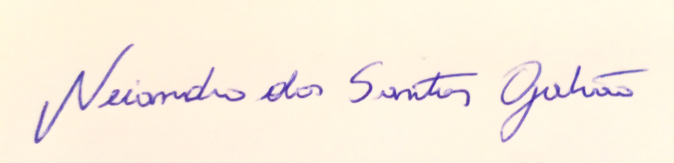

**Neiandro dos Santos Galvão**



**Antonione Santos Bezerra Pinto**

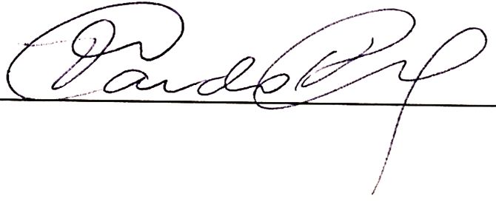

**Alan Leandro Carvalho de Farias**



**André Luiz Ferreira Costa**

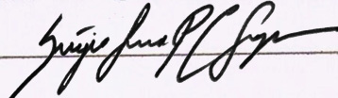

**Sérgio Lúcio Pereira de Castro Lopes**

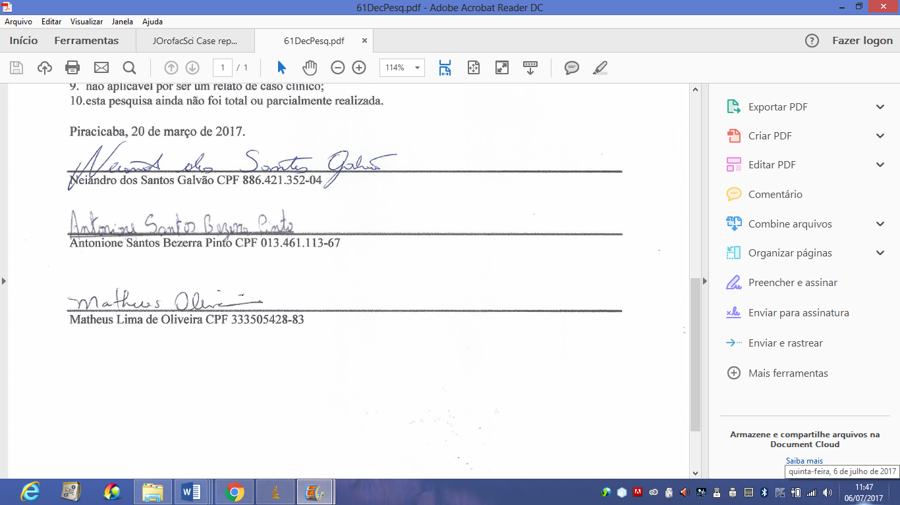

**Matheus Lima de Oliveira**