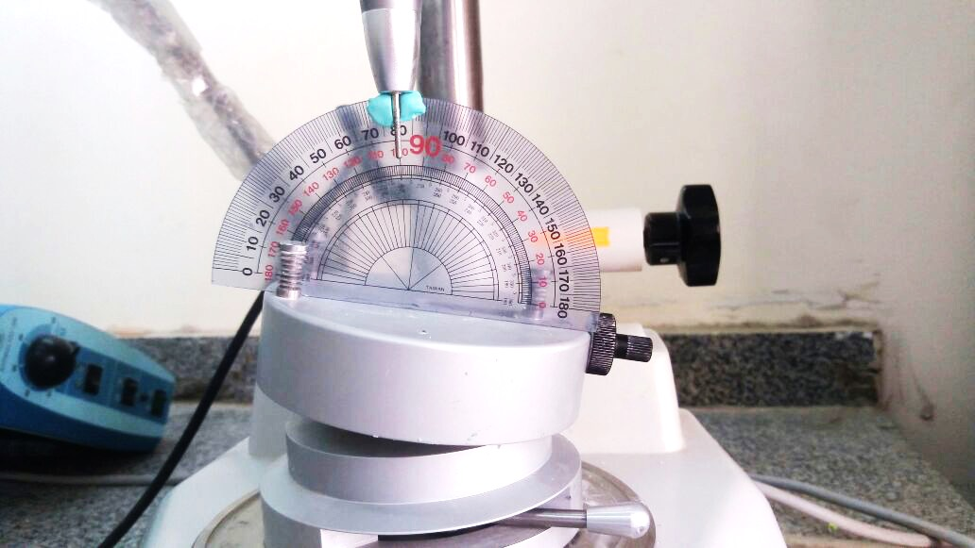

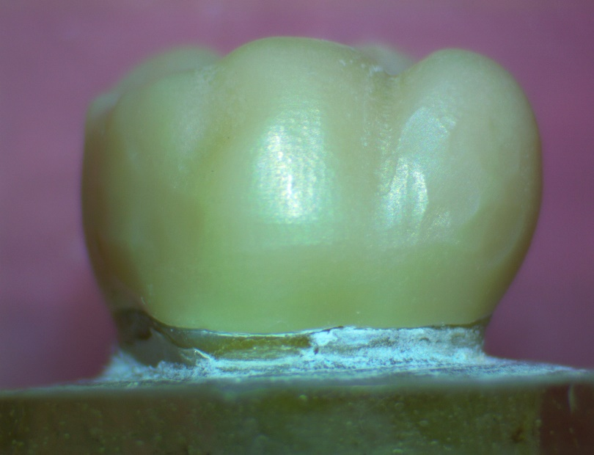

Fig. (1):10 degrees of taper on each surface. Fig. (2): Equidistant points of measurements on stereomicroscope

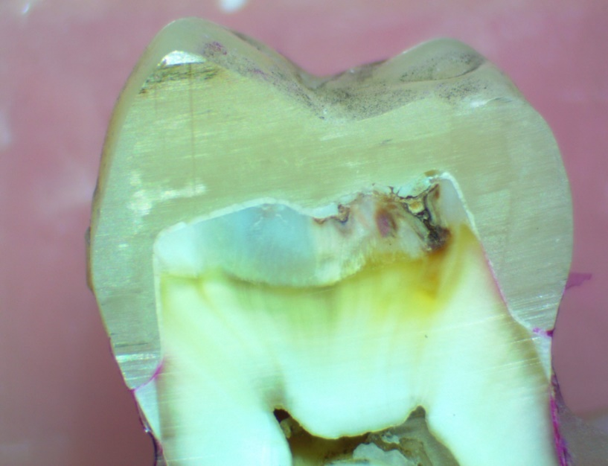

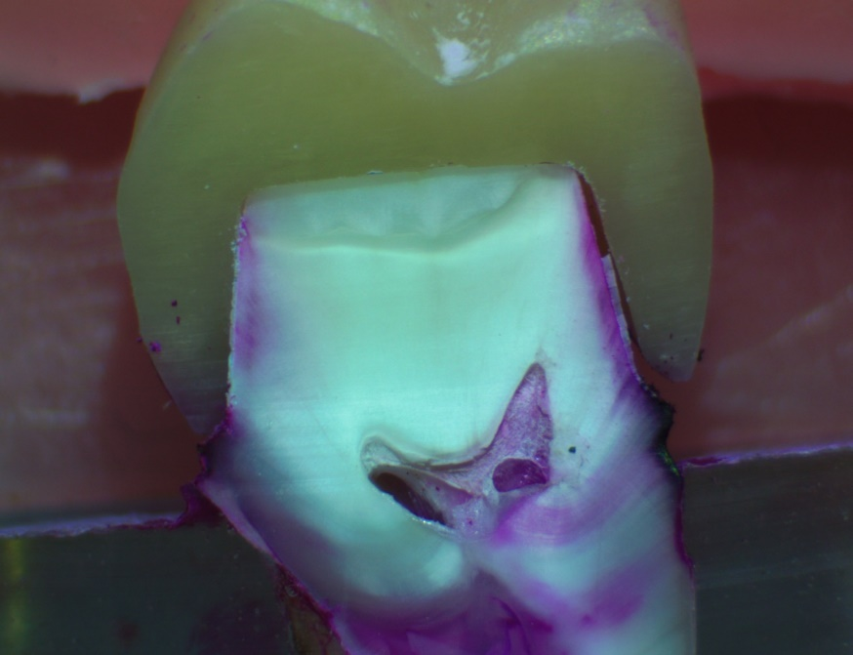

Fig. (4): Stereomicroscope image (group I) exhibits dye penetration to more than 2/3 of the axial wall (5)

(10x magnification)

Fig. (3): Stereomicroscope image (group I) exhibits dye penetration to more than 1/3 of the axial wall (4)

(10x magnification)

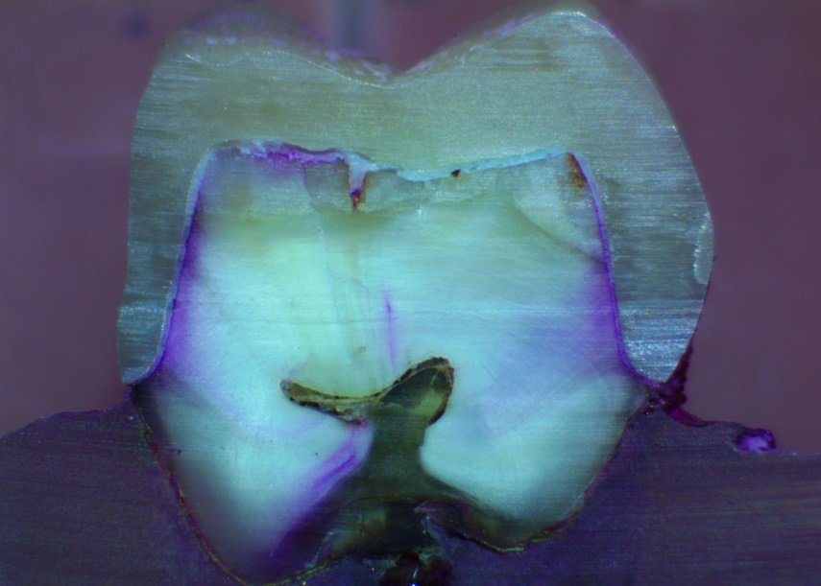

Fig. (6): Stereomicroscope image (group I) exhibits dye penetration exceeding the occlusal edge (7)

(10x magnification)

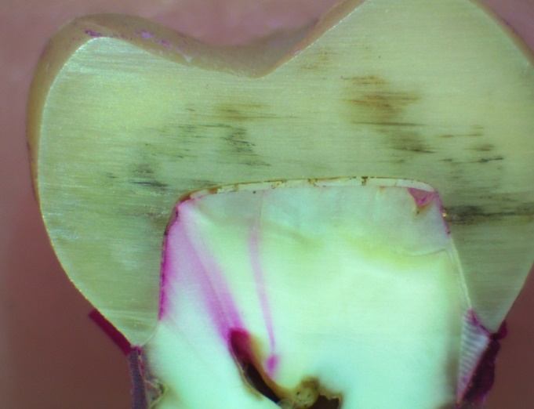

Fig. (5): Stereomicroscope image (group I) exhibits dye penetration to all of the axial walls including the occlusal edge (6)

(10x magnification)

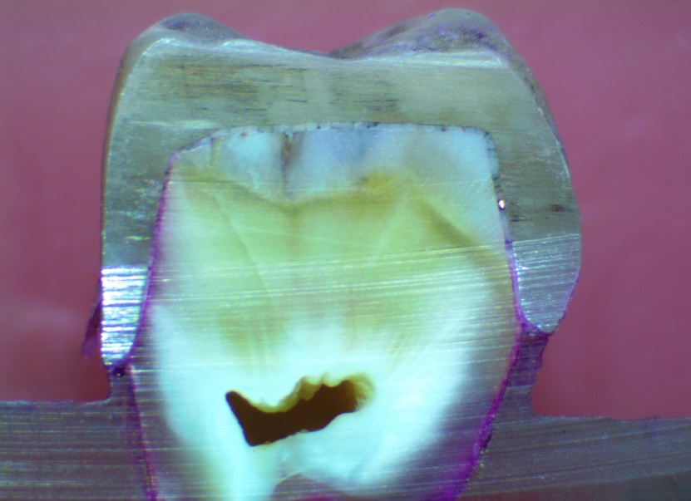

Fig. (7): Stereomicroscope image (group II) exhibits dye penetration to more than 2/3 of the axial wall (5)

(10x magnification)

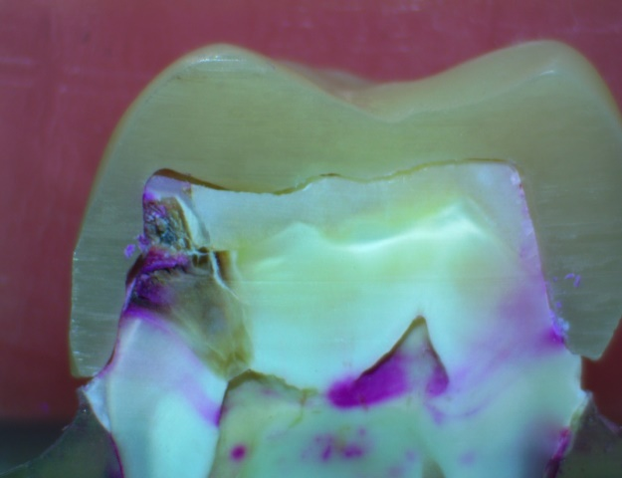

Fig. (8): Stereomicroscope image (group II) exhibits dye penetration to all the of the axial wall including the occlusal edge (6)

(10x magnification)

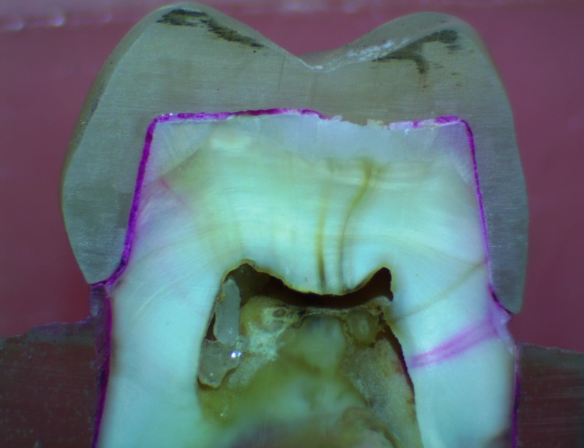

Fig. (9): Stereomicroscope image (group II) exhibits dye penetration to exceeding the occlusal edge (7)

(10x magnification)