COPYRIGHT TRANSFER AND RESPONSIBILITY STATEMENT

All manuscript's copyright ownership of the article " Differences in Quality of Life of Stunting Children based on Caries Status in Indonesia "
is transferred from the author(s) to the BRAZILIAN DENTAL SCIENCE, in the event the work is published. The manuscript has not been published elsewhere and that it has not been submitted simultaneously for publication elsewhere.
We hereby attest the study is original and does not present manipulated data, fraud or plagiarism. We made significant scientific contribution to the study and we are aware of the presented data and in agreement with the final version of the manuscript. We assume complete responsibility for the ethical aspects of the study.

Name: Fuad Husain Akbar |  | Name: Rini Pratiwi
ORCID: http://orcid.org/0000-0003-4819-4820 |  | ORCID: http://orcid.org/0000-0002-1825-0097
  Signature: |  | 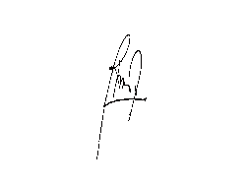  Signature:

Name: Nadiah Hulwa |  | Name:
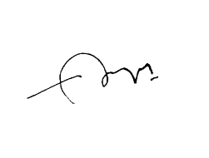  ORCID: https://orcid.org/0000-0002-4335-6539 |  | ORCID:
Signature: |  | Signature:

Name: |  | Name:
ORCID: |  | ORCID:
Signature: |  | Signature:

This text must be printed and signed by all authors. The scanned version should be submitted as supplemental file during the submission process.

