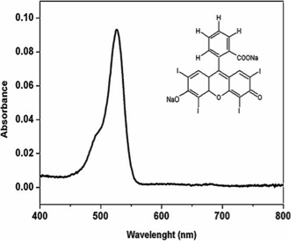
Figure 1. Chemical structure and absorption spectrum of erythrosine [43].

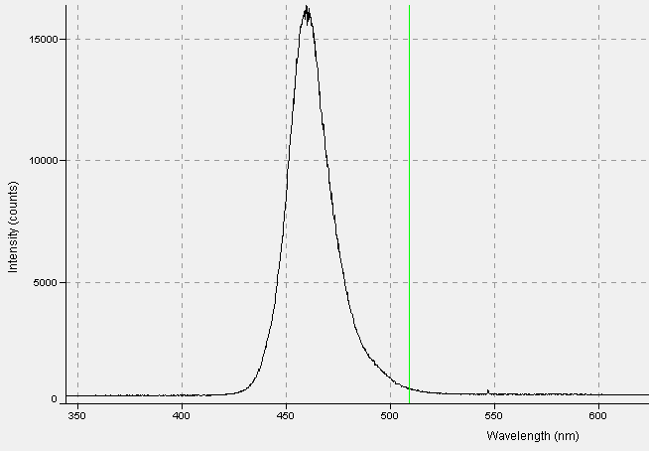
Figure 2. Emission spectrum of the blue LED (Emitter C, Schuster, Santa Maria, RS, Brazil).

Figure 3. Mean and standard deviation of the number of CFU/mL (log₁₀) obtained from PDI of planktonic cultures of S. mutans mediated by erythrosine 10 µM and blue LED, p = 0.3644.

Figure 4. Median values (crossbar), interquartile range (IQR box), minimum and maximum values of CFU/mL (log10) obtained from PDI of planktonic cultures of S. mutans mediated by erythrosine 10 µM and blue LED.

