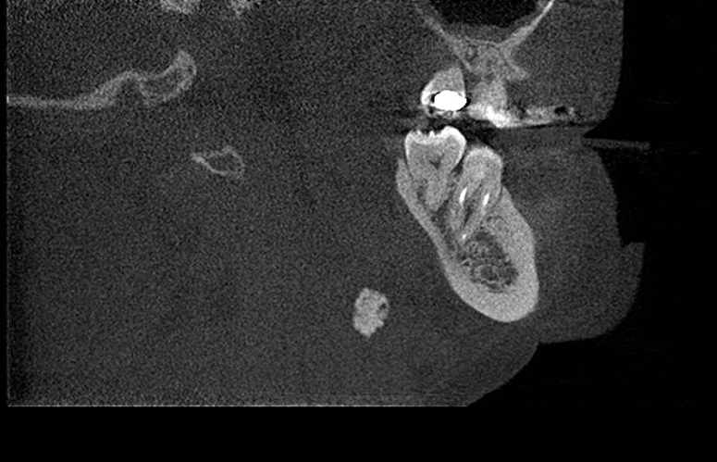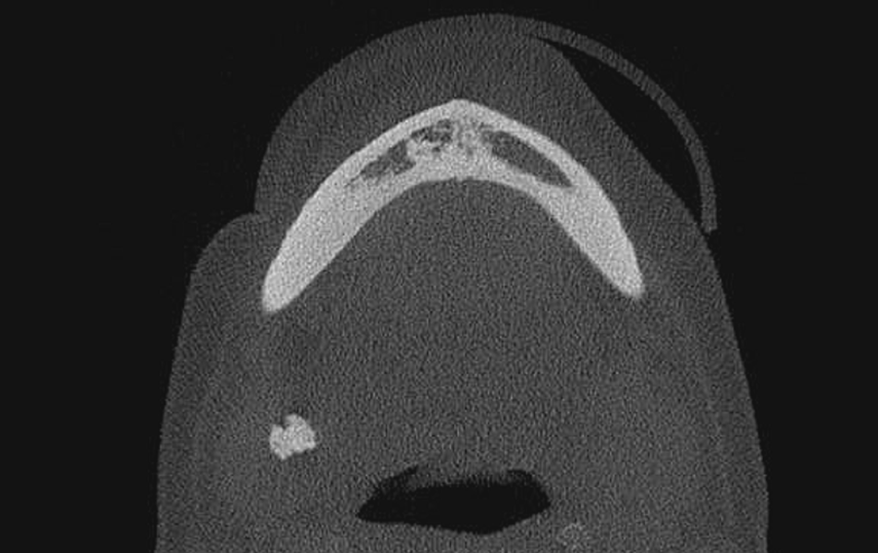
B
A
Figure 3- Sagittal views (A) and axial views (B) of the cone beam computed tomography showing the calcified lymph nodes.
Figure 3- Sagital section (A) and axial section (B) of the cone beam computed tomography showing the calcified carotid artery atheroma.

