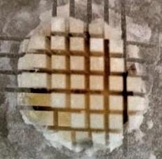
Figure( I): showing cutting of tooth with isomet as prepared for
microtensile bond strength test

Figure (II)&(III): scanning electron microscope reveling the effect of chitosan on the hybrid layer

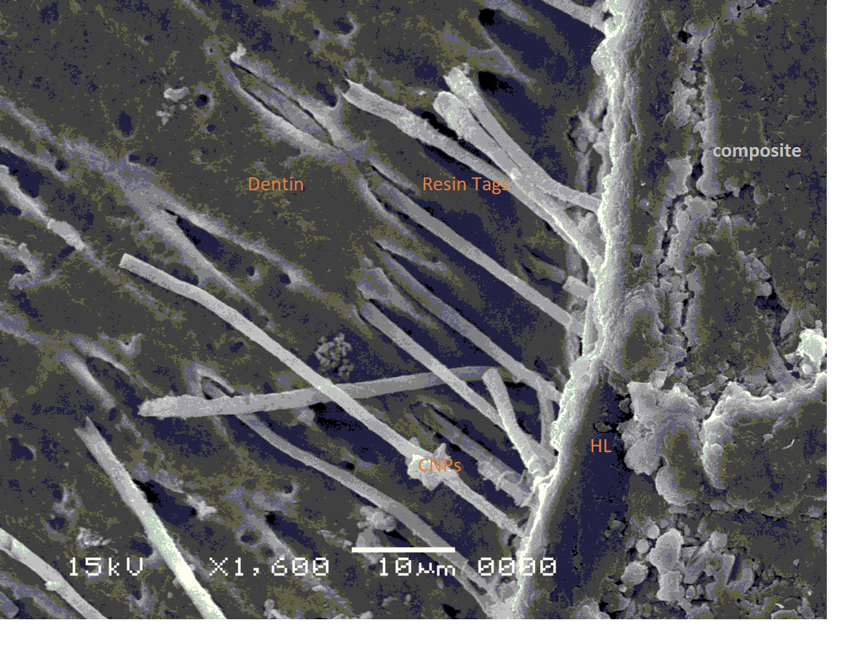

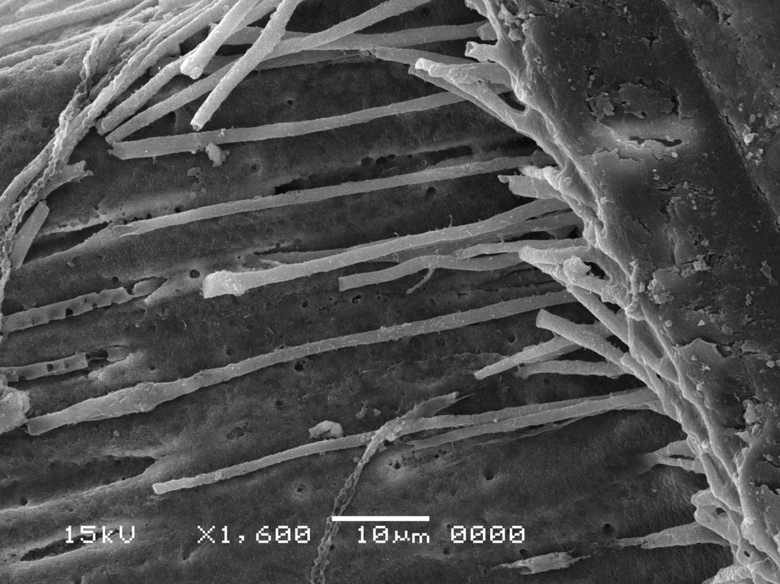

Figure( II&III) showing long resin tags with chitosan nanoparticles pretreated dentin
surface

