Author Agreement / Declaration

We declare that the manuscript, entitle: The finish line location of the cemented crown is an influencing factor? has not been previously published and is not currently under consideration for publication elsewhere, nor will the research reported be submitted for publication elsewhere until a final decision has been made as to its acceptability Brazilian Dental Science.
We wish to confirm that there are no known conflicts of interest associated with this publication. All institutional or corporate affiliations of mine and all funding sources supporting the work are acknowledged (The CAPES Foundation of Department of Education and National Council for Scientific and Technological Development supported this work).
We confirm that we have given due consideration to the protection of intellectual property associated with this work and that there are no impediments to publication, including the timing of publication, with respect to intellectual property. In so doing we confirm that we have followed the regulations of our institutions concerning intellectual property.
We confirm that the manuscript has been read and approved by all named authors and that there are no other persons who satisfied the criteria for authorship but are not listed. We further confirm that the order of authors listed in the manuscript has been approved by all of us.
We further confirm that any aspect of the work covered in this manuscript that has involved experimental human dental has been conducted with the ethical approval of all relevant bodies and that such approvals are acknowledged within the manuscript (approved by the Ethics Committee of Piracicaba Dental School, University of Campinas, Piracicaba, Brazil, protocol CAAE 66767417.6.0000.5418).
We understand that the Corresponding Author is the sole contact for the Editorial process (including Editorial Manager and direct communications with the office). He is responsible for communicating with the other authors about progress, submissions of revisions and final approval of proofs. We confirm that we have provided a current, correct email address which is accessible by the Corresponding Author and which has been configured to accept email from e_angelo10@hotmail.com.
Signed by all authors as follows:

_________________________________________
Enrico Angelo

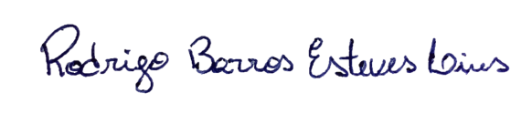

_________________________________________
Rodrigo Barros Esteves Lins
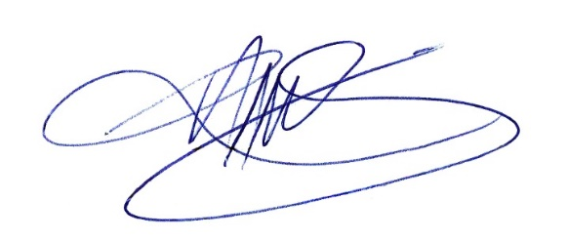

_________________________________________
Luís Roberto Marcondes Martins

