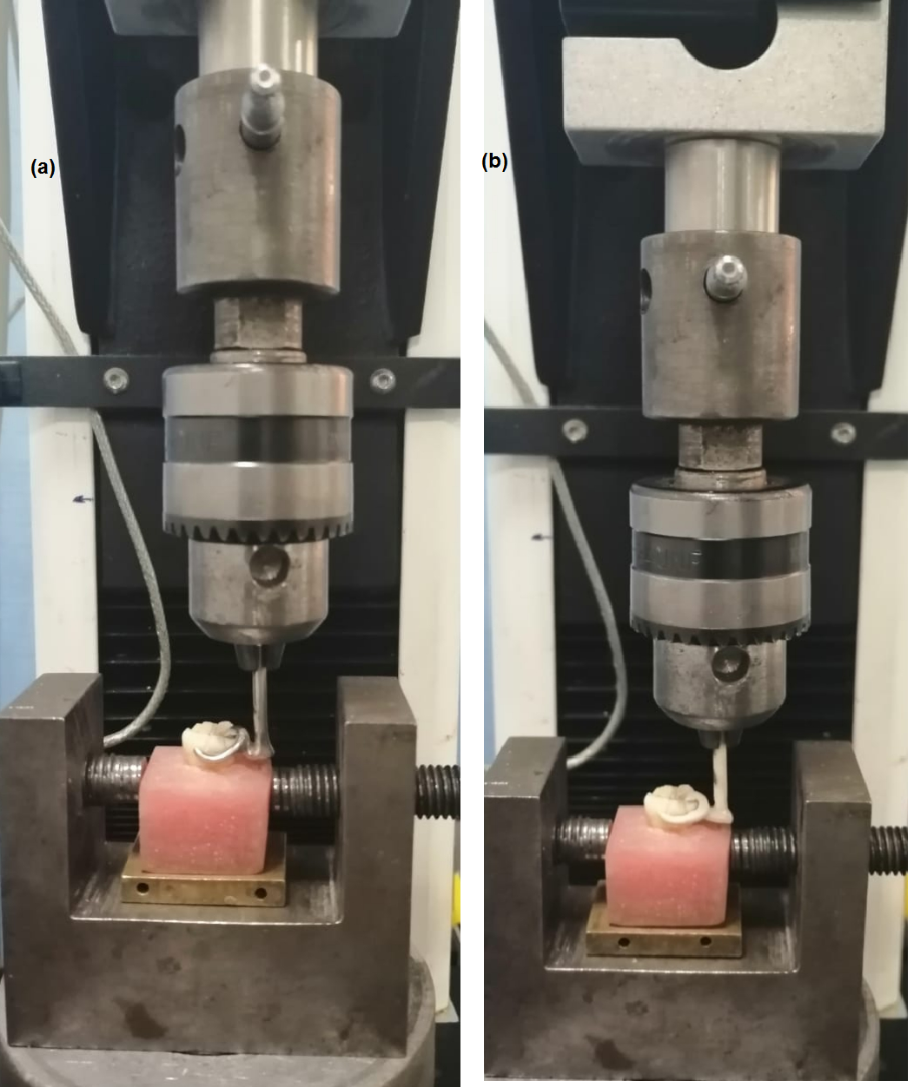
Fig. 1 Each clasp and its abutment were mounted inside the universal testing machine ,
(a) Co-Cr clasp, (b) PEEK clasp.

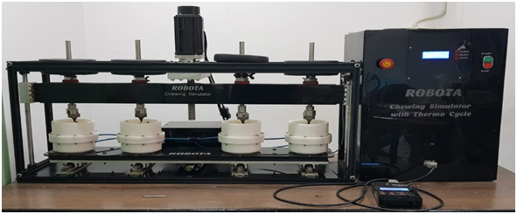
Fig. 2 The chewing simulator.

