COPYRIGHT TRANSFER AND RESPONSIBILITY STATEMENT

All manuscript's copyright ownership of the article "IMPACT OF PRENATAL PROTEIN-CALORIE MALNUTRIT" is transferred from the author(s) to the BRAZILIAN DENTAL SCIENCE, in the event the work is published. The manuscript has not been published elsewhere and that it has not been submitted simultaneously for publication elsewhere.
We hereby attest the study is original and does not present manipulated data, fraud or plagiarism. We made significant scientific contribution to the study and we are aware of the presented data and in agreement with the final version of the manuscript. We assume complete responsibility for the ethical aspects of the study.

Authors: Juliana Schaia Rocha, Márcia Helena Baldani Pinto, Célia Maria da Lozzo Lopes
Signatures:

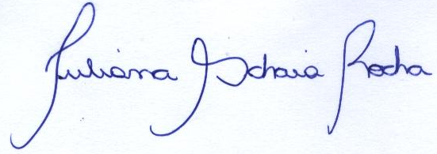

Juliana Schaia Rocha Márcia Helena Baldani Pinto

August 19, 2013

