

São Paulo, 29/08/2013

COPYRIGHT TRANSFER AND RESPONSIBILITY STATEMENT

"Conservative esthetic treatment of a discoloured calcified permanent tooth: Five-year clinical evaluation” is transferred from the author(s) to the BRAZILIAN DENTAL SCIENCE, in the event the work is published. The manuscript has not been published elsewhere and that it has not been submitted simultaneously for publication elsewhere.
We hereby attest the study is original and does not present manipulated data, fraud or plagiarism. We made significant scientific contribution to the study and we are aware of the presented data and in agreement with the final version of the manuscript. We assume complete responsibility for the ethical aspects of the study.

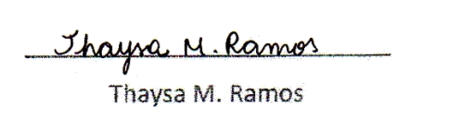
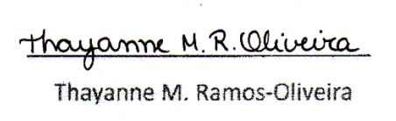
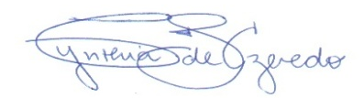
Cynthia Soares de Azevedo
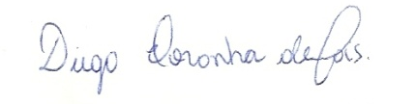
_________________________

Diego Noronha de Góis
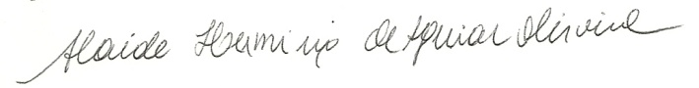
___________________________
Alaíde Herminia A. Oliveira
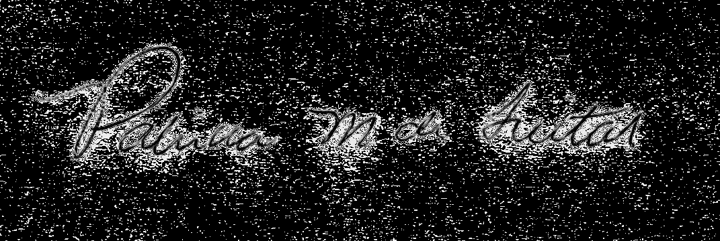
_________________________
Patricia Moreira de Freitas

