Manuscript’s title in English
Title in Portugues (only for Brazilian native speakers authors)

Abstract:
Abstracts should provide a clear and structured overview of the systematic review. Authors are strongly encouraged to use the following headings: Background: Briefly describe the context and significance of the research topic, including gaps in current knowledge. Objective: State the specific research question or objective guiding the review. Methods: Summarize the search strategy, inclusion criteria, data sources, and methods used for study selection and synthesis. Results: Present the number of studies included, key findings, and patterns or trends identified across the literature. Interpret the main findings in relation to the existing evidence base, noting strengths, limitations, and implications. Conclusions: Highlight the main interpretations, practical applications, and recommendations for research or clinical practice.
The abstract must accurately reflect the content of the review, avoid overstating conclusions, and include only results supported by the main text.

Resumo:
Xxxxxx xxxxxx xxxxxx xxxxxx xxxxxx xxxxxx xxxxxx xxxxxx xxxxxx xxxxxx xxxxxx Xxxxxx xxxxxx xxxxxx xxxxxx xxxxxx xxxxxx xxxxxx xxxxxx xxxxxx xxxxxx xxxxxx Xxxxxx xxxxxxx xx (Abstract in Portuguese only for Brazilian native speakers authors).

Keywords: Xxxxxxx; Xxxxxxx; Xxxxxxx; Xxxxxxx; Xxxxxxx. (5 terms from the Medical Subject Headings list, in alphabetical order).

Palavras-chave: Xxxxxxx; Xxxxxxx; Xxxxxxx; Xxxxxxx; Xxxxxxx. (The translated 5 terms in Portuguese only for Brazilian native speakers authors).

Introduction
The Introduction section of a systematic review in dentistry should clearly define the clinical question and explain its relevance to oral health practice or research. It must provide a concise overview of existing literature, identifying gaps or inconsistencies that justify the need for the review [1]. Authors should describe the rationale for conducting the review and how it aims to synthesize current evidence. In alignment with EQUATOR Network standards, such as PRISMA, the introduction should promote transparency and contextual clarity. This section sets the foundation for the methodology and guides readers toward the significance of the findings [2,3].

Methods
The Methods section of a systematic review in dentistry should detail the study protocol with transparency and reproducibility. Authors must describe the eligibility criteria, search strategy, databases consulted, and the time frame of the literature search. It should include the process for study selection, data extraction, quality assessment, and specifying tools used (e.g., PRISMA, AMSTAR). Any statistical methods for data synthesis or meta-analysis must be clearly explained. Following EQUATOR Network guidelines ensures methodological rigor and enhances the credibility of the review [4].

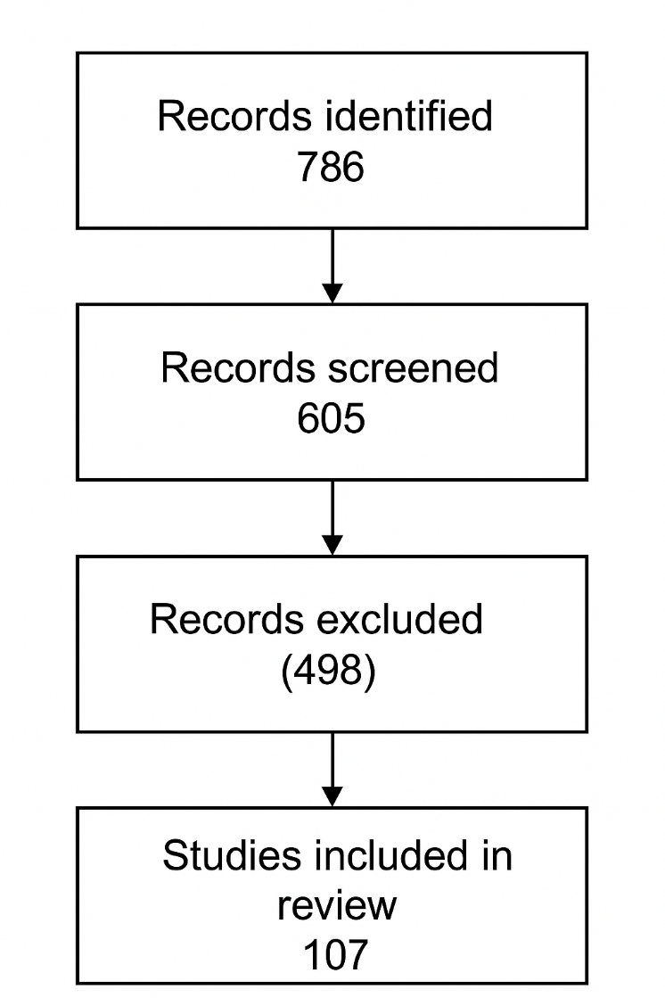
Figure 1 - This is a figure. Schemes follow the same formatting and should be numbered with roman numbers.

Results
The Results section of a systematic review in dentistry should present the findings in a clear, structured, and unbiased manner. Authors must report the number of studies included, their characteristics, and the outcomes relevant to the research question. Data synthesis—whether qualitative or quantitative—should be transparently described, including any subgroup analyses or sensitivity tests. In accordance with EQUATOR Network guidelines such as PRISMA, results should be supported by tables, figures, and summary statistics. Any deviations from the protocol or missing data must be acknowledged to ensure transparency and reproducibility.
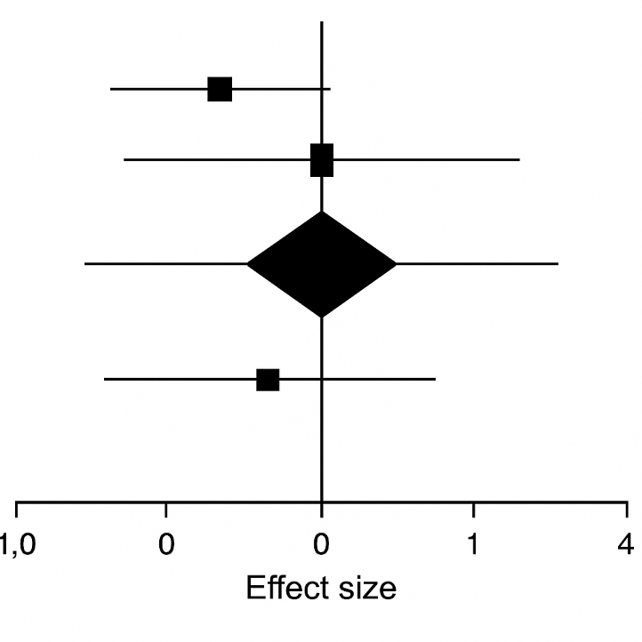
Figure 2 - This is a figure. Schemes follow the same formatting and should be numbered with roman numbers.

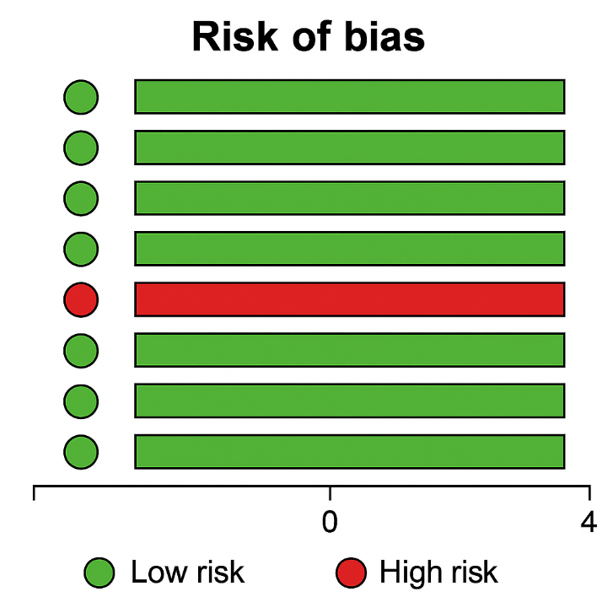
Figure 3 - This is a figure. Schemes follow the same formatting and should be numbered with roman numbers.

Table I. This is a table. Tables should be placed in the main text near to the first time they are cited and numbered with roman numbers.
Title 1 | Title 2 | Title 3¹
entry 1 | data* | data
entry 2 | data* | data
¹ Tables may have a footer.
*p < 0.05.

Discussion
The Discussion section of a systematic review in dentistry should interpret the synthesized findings in the context of existing literature, highlighting consistencies, discrepancies, and implications for clinical practice. Authors must critically assess the strength and limitations of the evidence, including methodological quality and risk of bias. In line with EQUATOR Network guidelines such as PRISMA, the discussion should be transparent, balanced, and avoid overstating conclusions. It should also address the applicability of results to different populations or settings and suggest directions for future research. A thoughtful discussion enhances the relevance and impact of the review. [1-4].

Conclusion
The Conclusion section of a systematic review in dentistry should succinctly summarize the main findings and their implications for clinical practice, policy, or future research. Authors must ensure that conclusions are directly supported by the synthesized evidence and avoid overstating results. In accordance with EQUATOR Network guidelines such as PRISMA, the section should reflect transparency, clarity, and alignment with the review’s objectives. Limitations of the evidence base and potential areas for further investigation should be acknowledged. A well-structured conclusion reinforces the relevance and impact of the review within the dental field.

Acknowledgments
In the Acknowledgement section, authors must include individuals and organizations that have made substantive contributions to the research or the manuscript. An exception is where funding was provided, which should be included in Funding Sources. Please refer to the Guidelines issued by the ICMJE to determine non-author contributors that should be included in the Acknowledgement section.

Funding
Authors must give full details about the funding of any research relevant to their study, including sponsor names and explanations of the roles of these sources in the preparation of data or the manuscript. If no funding has been provided for the research, please include the following sentence: “This research did not receive any specific grant from funding agencies in the public, commercial, or not-for-profit sectors.”

Conflict of Interest
Authors are required to disclose any possible conflicts of interest. All forms of support and financial involvement (e.g. employment, consultancies, honoraria, stock ownership and options, expert testimony, grants or patents received or pending, royalties) which took place in the previous three years should be listed, regardless of their potential relevance to the paper. Also the nonfinancial relationships (personal, political, or professional) that may potentially influence the writing of the manuscript should be declared. If there is no conflict of interest, please state: “The authors have no conflicts of interest to declare.”

Regulatory Statement
Authors submitting a systematic review to this journal must include a regulatory statement that addresses the following components:
- Ethical Oversight: Indicate whether the review protocol was registered (e.g., PROSPERO) and provide the registration number. If no registration was performed, explain why.
- Compliance with Reporting Guidelines: State that the review adheres to the Preferred Reporting Items for Systematic Reviews and Meta-Analyses (PRISMA 2020) guidelines, as recommended by the EQUATOR Network.
- Data Transparency: Mention whether the data extraction forms, analytic code, and datasets used in the review are publicly available, and specify where they can be accessed.
- Ethical Considerations for Included Studies: Confirm that ethical approval and informed consent were obtained for all primary studies included in the review, or state if such information was unavailable.

References (Vancouver referencing, numerically cited):

- de Carvalho Ramos N, Augusto MG, Alves LM, Kleverlaan CJ, Dal Piva AM. Wear of dental ceramics. Brazilian Dental Science. 2023 Jan 1;26(1).
- De Andrade GS, Kalman L, Giudice RL, Adolfi D, Feilzer AJ, Tribst JP. Biomechanics of implant-supported restorations. Brazilian Dental Science. 2023 Jan 1;26(1).
- da Silva TM, de Faria Petrucelli N, de Mendonça RP, da Silva Júnior JP, Campos TM, de Paiva Gonçalves SE. Impact of photoinitiator quality on chemical-mechanical properties of dental adhesives under different light intensities. Brazilian Dental Science. 2023 Jan 1;26(1).
- da Silva Tricoly T, Ferreira CL, da Silva Lima VC, de Marco AC, Caneppele TM, Jardini MA. Is the use of Lactobacillus reuteri probiotic efficient as adjunctive therapy in the treatment of periodontitis? A systematic review. Brazilian Dental Science. 2023 Feb 24;26(1).

Attention! This template was designed for Systematic reviews and Metanalysis. For more details about Manuscript preparation or requested heading for Original Article / Case Report or Clinical Technique Manuscripts, please visit the Author Guidelines at Submissions | Brazilian Dental Science (unesp.br)

